**Blog Tracker Application**

**Capstone Project**

**Aim:**

To create a Full Stack Application that allows employees to add their blog-related details and show all blogs written by employees on the home page and to allow admin to add,update,delete employee details.

**GitHub link:**

[**https://github.com/Sukirthalakshmanan1/blogs**](https://github.com/Sukirthalakshmanan1/blogs)

**Procedure:**

* Create an ASP.NET Web application.Select WEB API application and enable docker.
* Create a Library(DAL)Data Access Layer and Create a class EmpInfo,AdminInfo,BlogInfo in Code first Approach and set necessary properties.
* Download Entity Framework
* Create a Business Logic Layer(BLL) and set the properties.
* Here the database is connected to Azure and Write the connection string in Web.config and App.config
* Create EmpOperations and perform the insert,update,delete,List,search EmpInfo operations in DAL Library.
* Create BlogOperations and perform the insert,update,delete,List,search BlogInfo operations in DAL Library.
* In AdminInfo class use DropCreateDatabaseIfModelChanges<ContextClass> and add some default data into the AdminInfo table by overriding the Seed method.
* Add dependencies for the Project.
* Add controller named Emps and Add methods GET,POST,PUT,Delete,search methods and access the operation with the help of EmpOperations class.
* Add model class Emp.cs in Model Folder and write the necessary properties.
* Add controller named Blog and Add methods GET,POST,PUT,Delete,search methods and access the operation with the help of BlogOperations class.
* Add model class BlogModel.cs,AdminModel.cs in Model Folder and write the necessary properties.
* Create an ASP.Net Web Application and select MVC and enable docker.
* Create Web API (Blog,Employee)controllers and write necessary operations.
* Create views for BlogUI(Login,Index,create,Details,Delete,Edit)
* Create views for EmpUI(Login,Index,create,Details,Delete,Edit)
* Download Postman Application and create an account.
* Run the project and copy the URL and paste it in Postman.
* Test the Method GET() to get All Employee details and blog details
* POST Method–To Insert Employee,blog details in the database.
* PUT-To update employee details using PassCode,and to update blog details using BlogId.
* Delete–To delete Employee details based on PassCode and to delete Blogdetails using BlogId.
* To (find) search the Employee details with Passcode and Blogdetails using BlogId.
* Download Nunit,NUnitTestAdapter
* Write Unit Testing for Admin class and Employee class.
* Test the Classes and run all the Test cases.
* Create a new Git Repository and push the code to GitHub
* Open Jenkins and create new item -> free style project and click ok.
* Go to configure and go to Github repository and paste the Github link
* And write your credentials
* Save and build
* After successful build go to configure and and add visual studio
* And copy the msbuild path and paste and save
* Build now
* On successful build Console Output is shown.

**Output:**

**Home Page:**

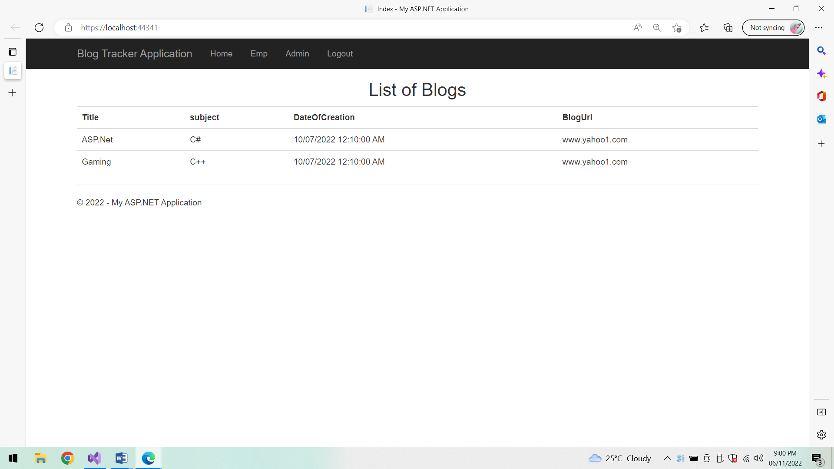

**Admin login:**

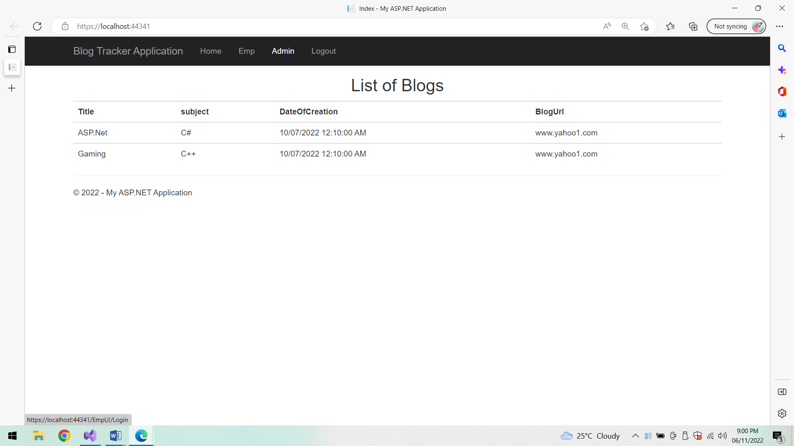

**Admin Login page:**

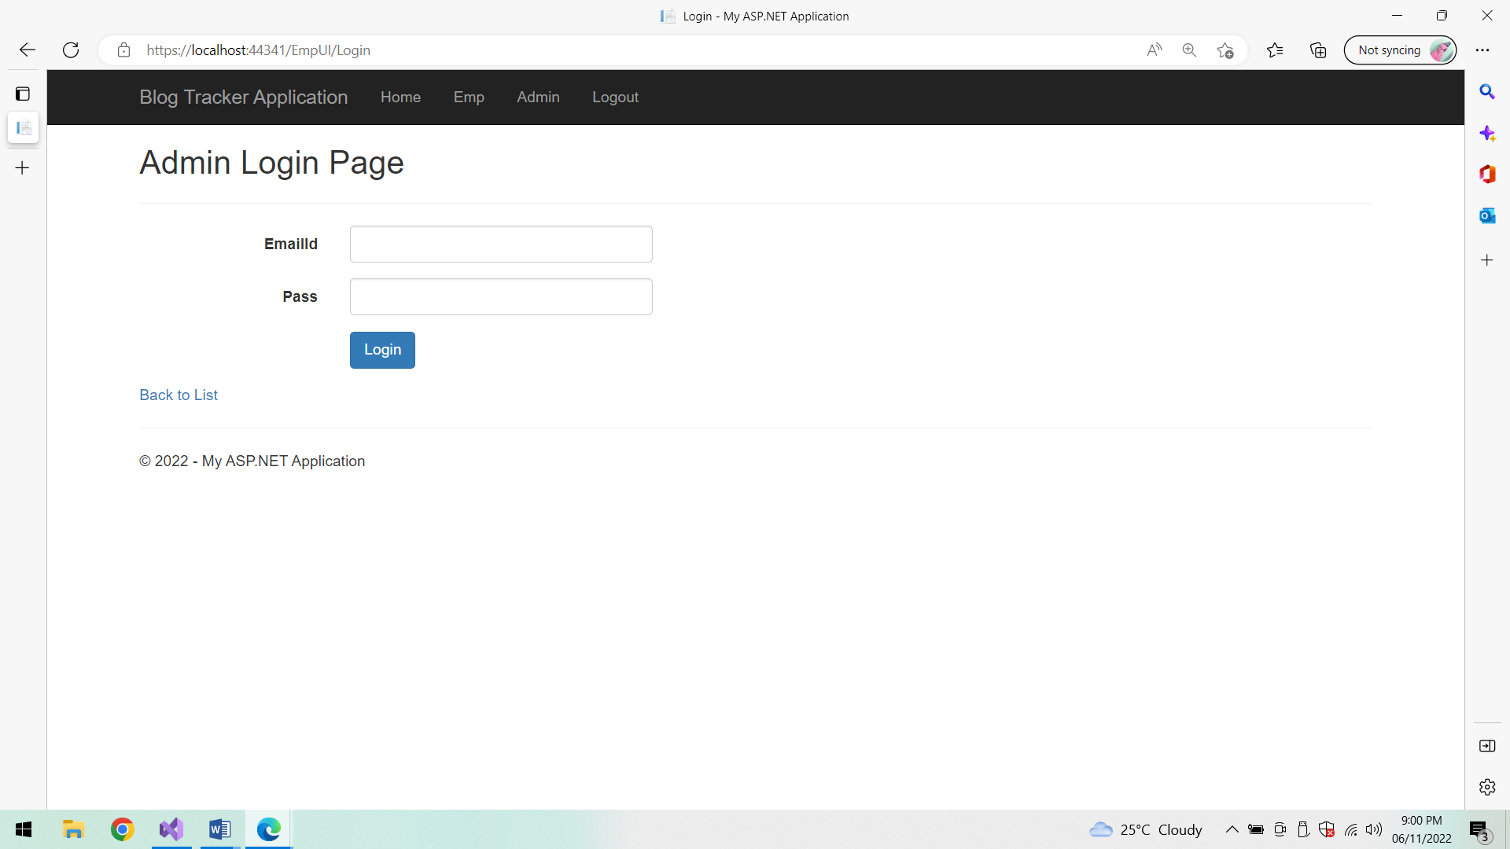

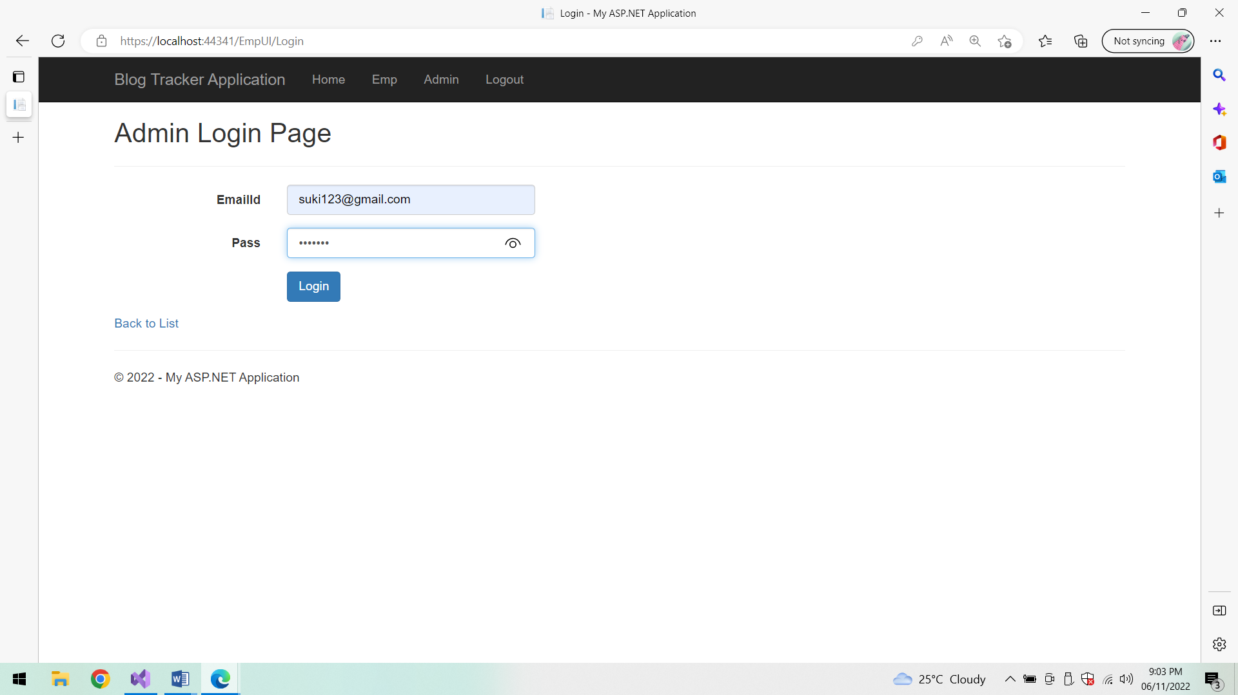

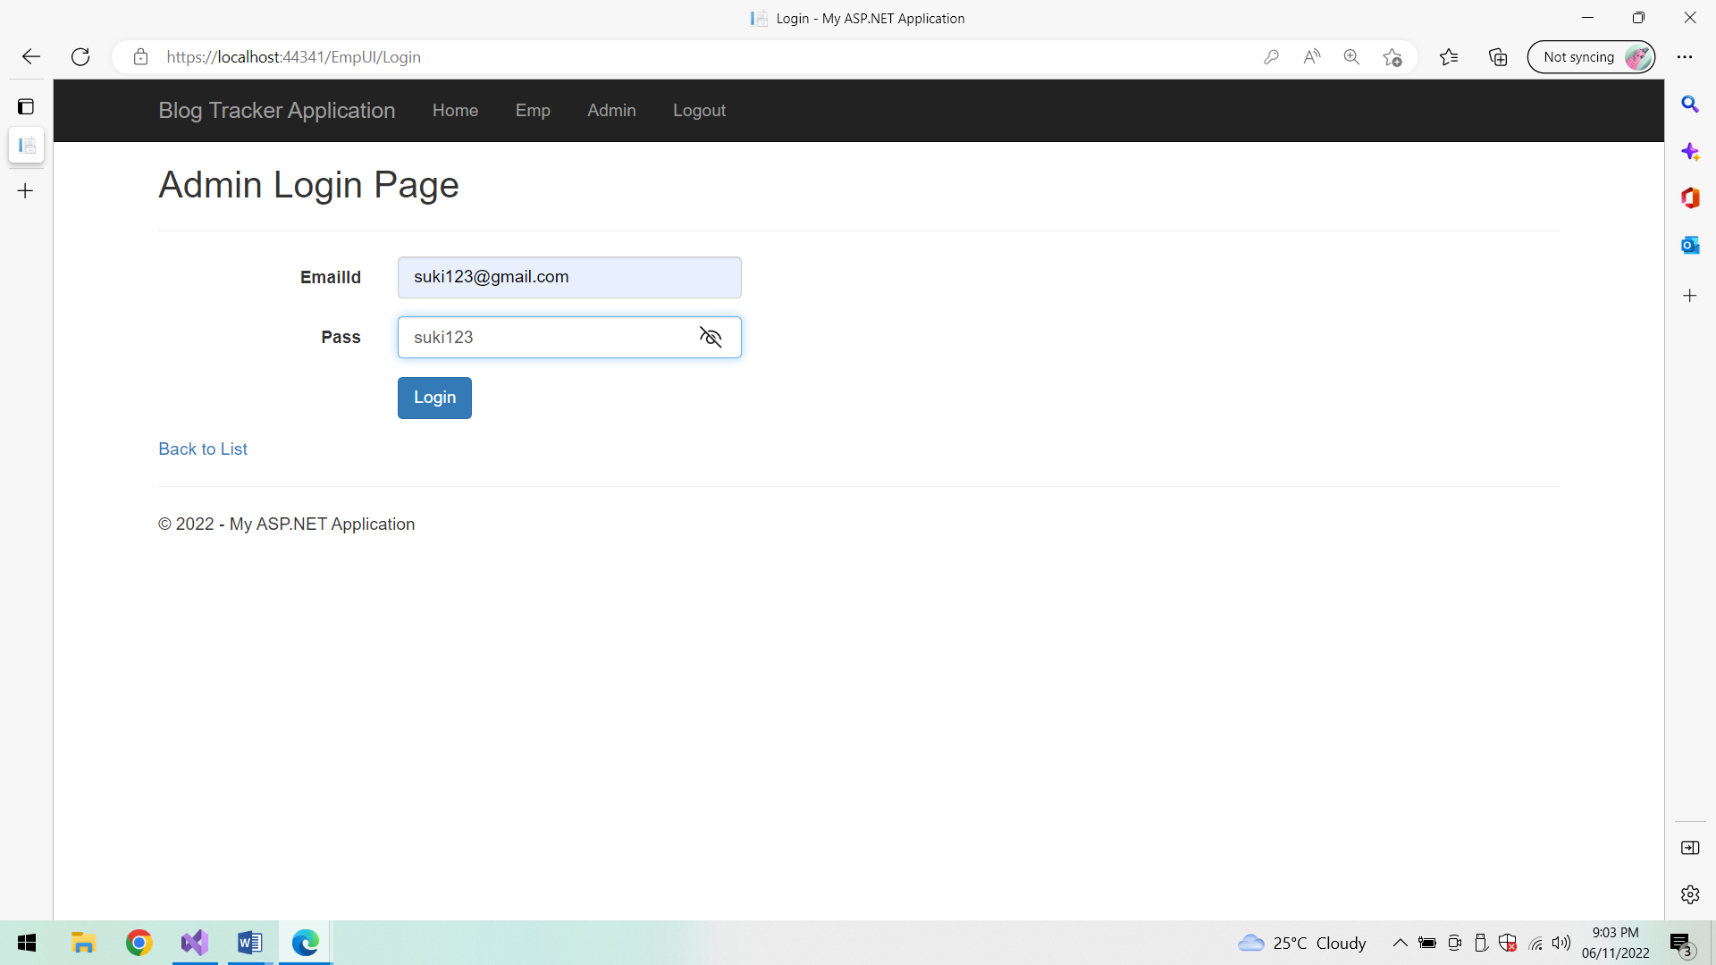

**Logging in:**

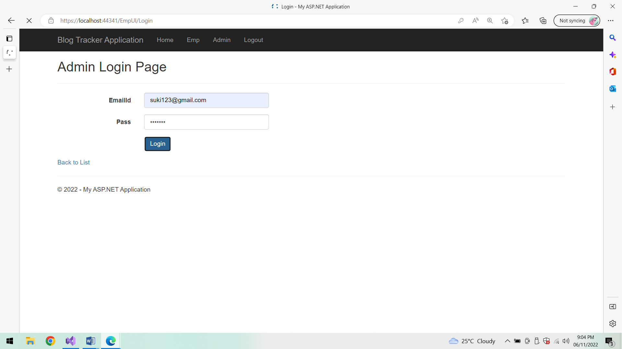

**Employee List:**

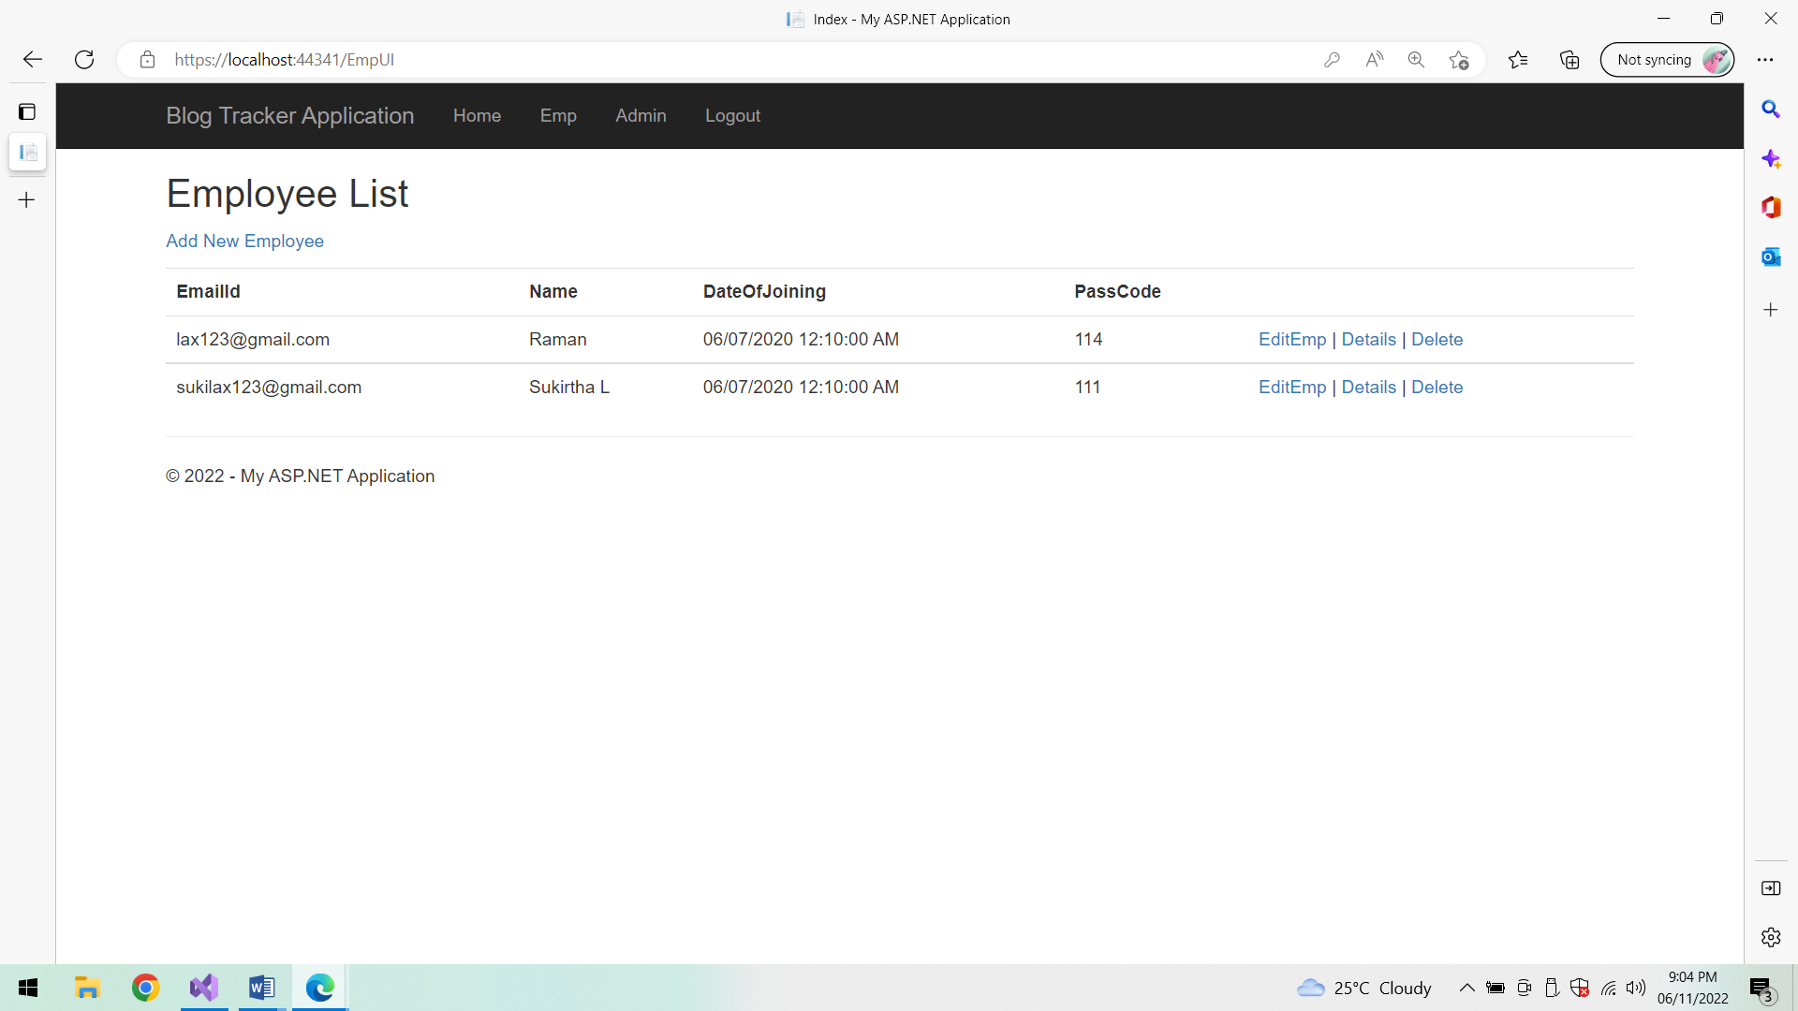

**Add New Employee:**

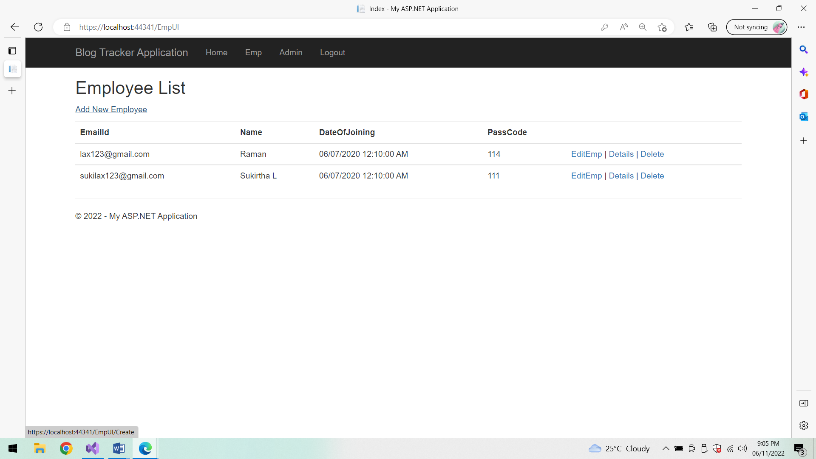

**Employee Details:**

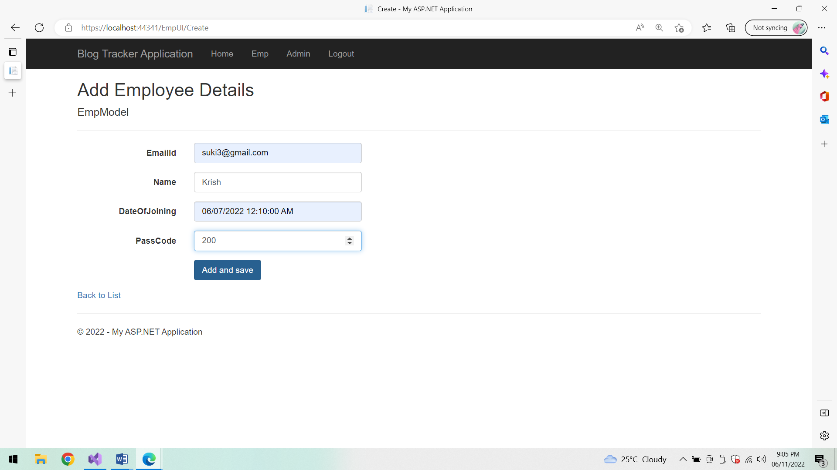

**After Adding Employee details:**

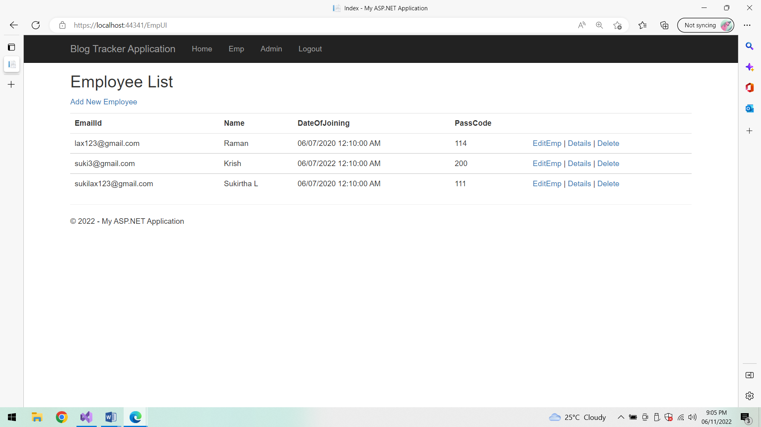

**Edit Employee details:**

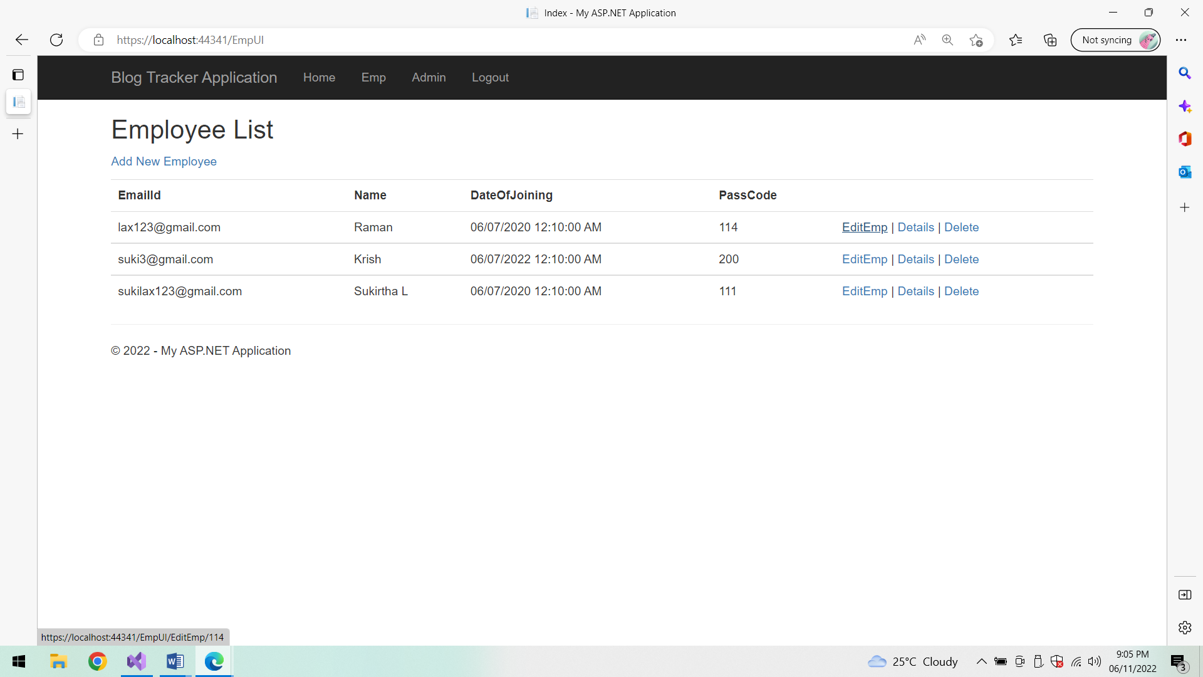

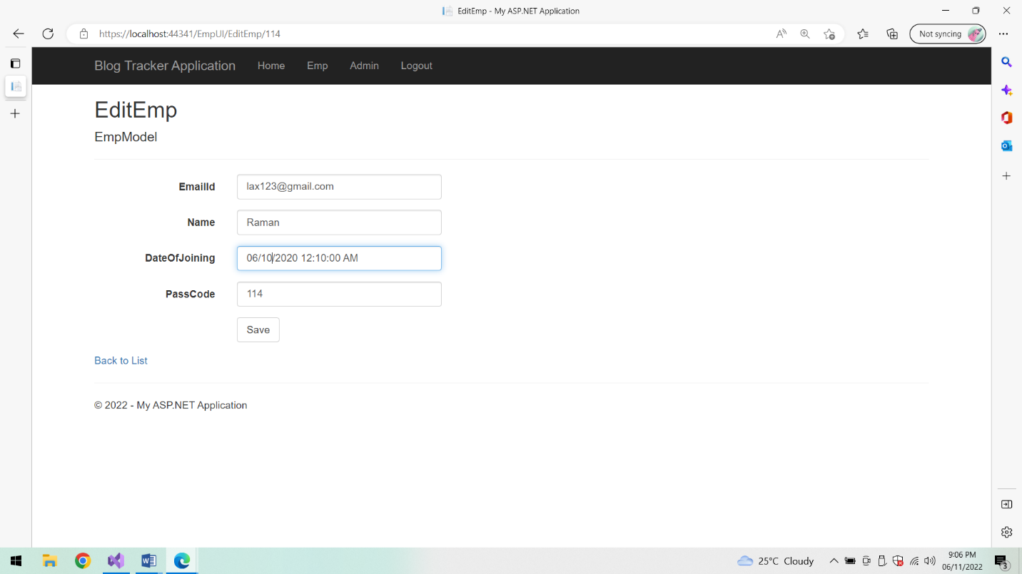

**After Editing:**

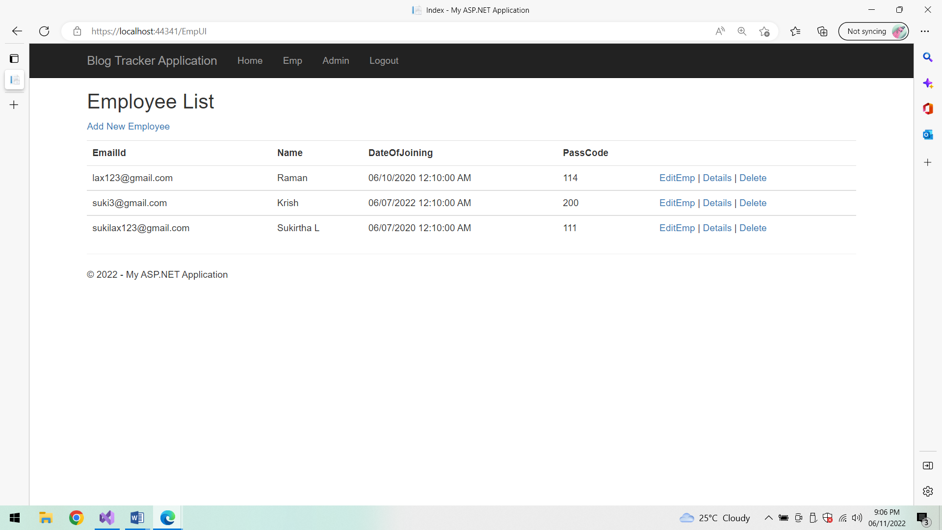

**Details:**

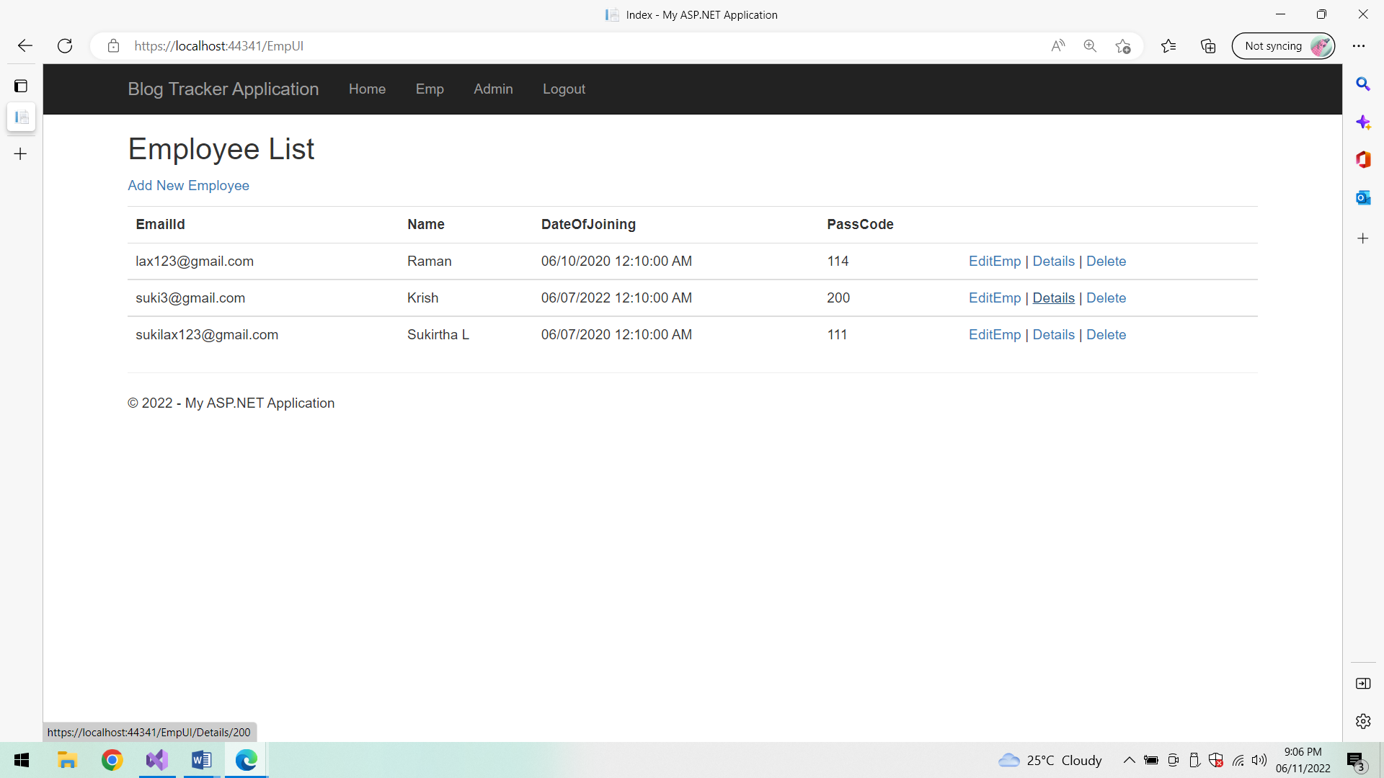

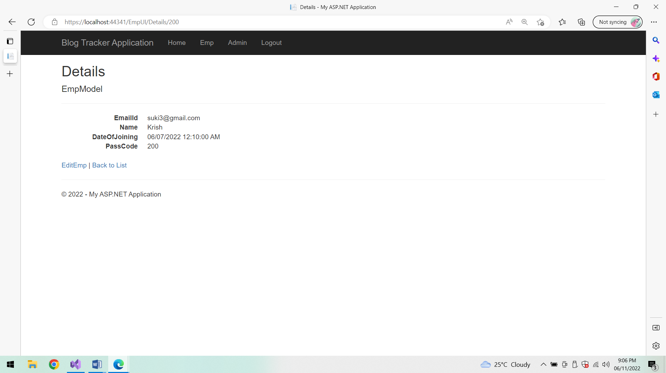

**Edit Employee details:**

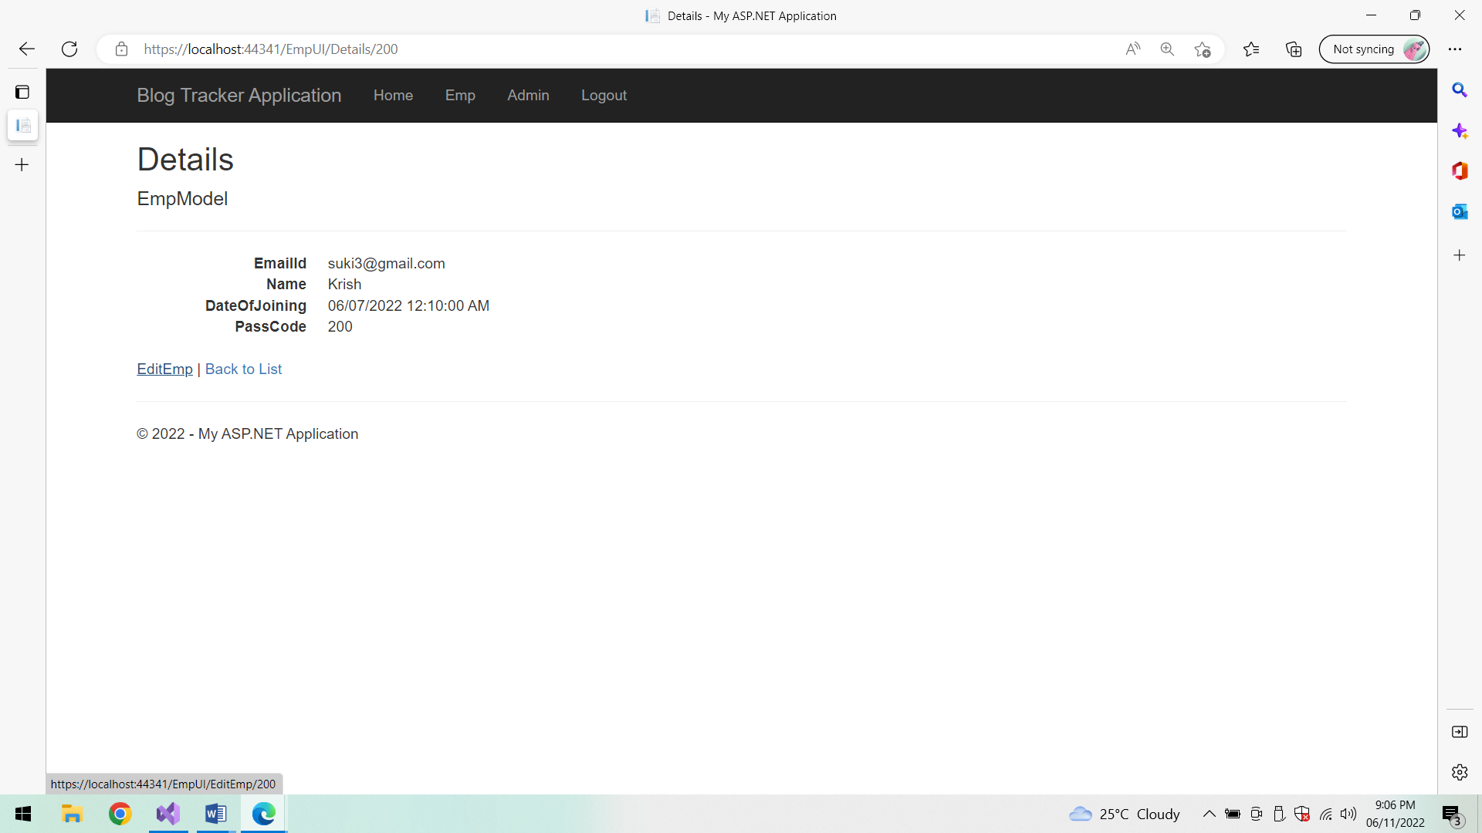

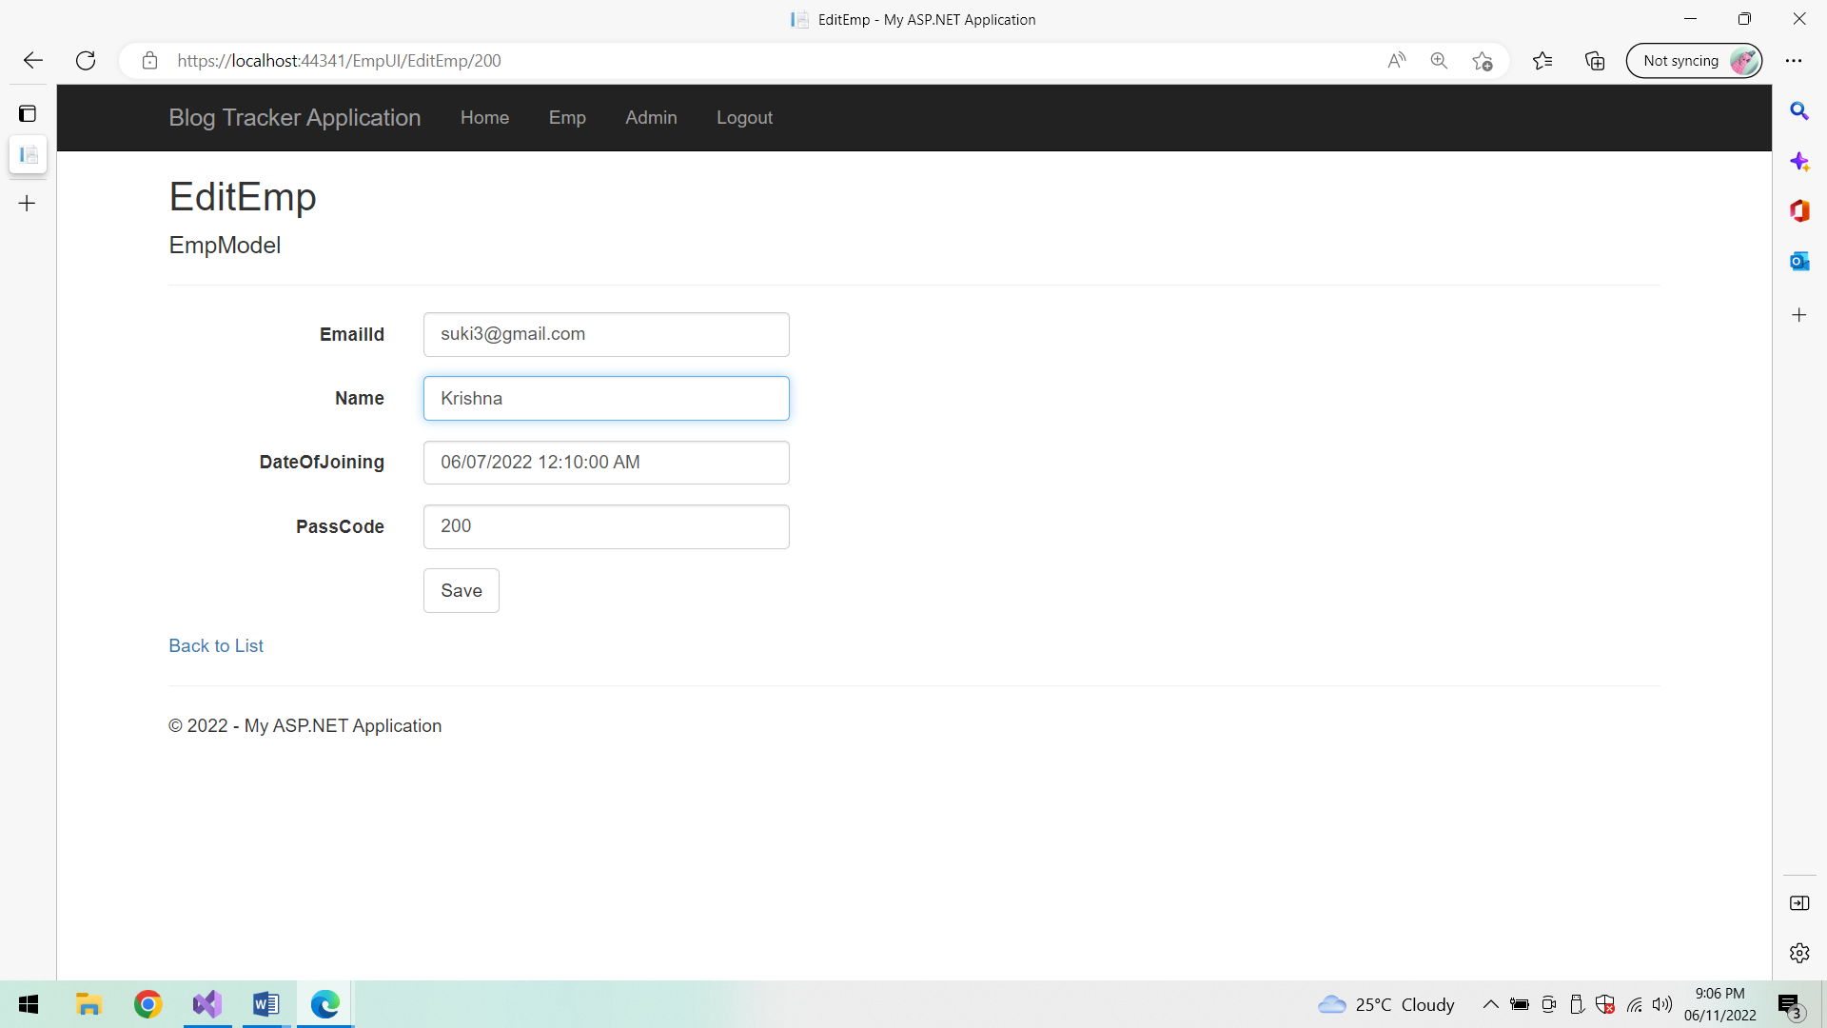

**After Editing:**

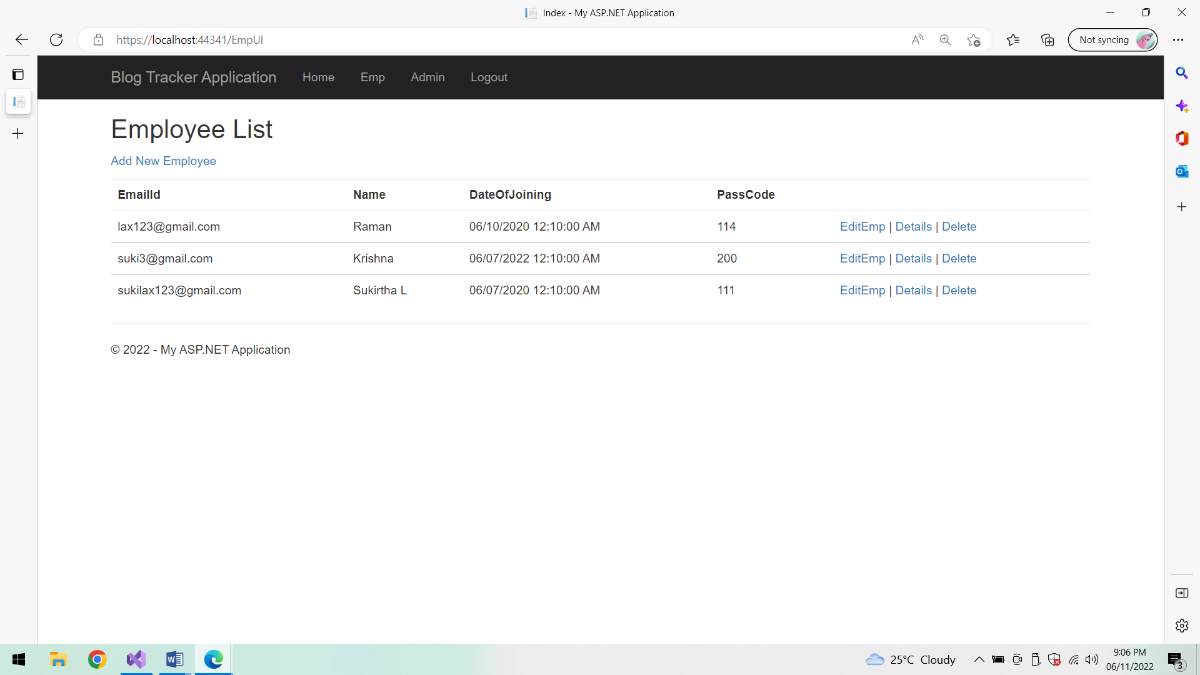

**Delete:**

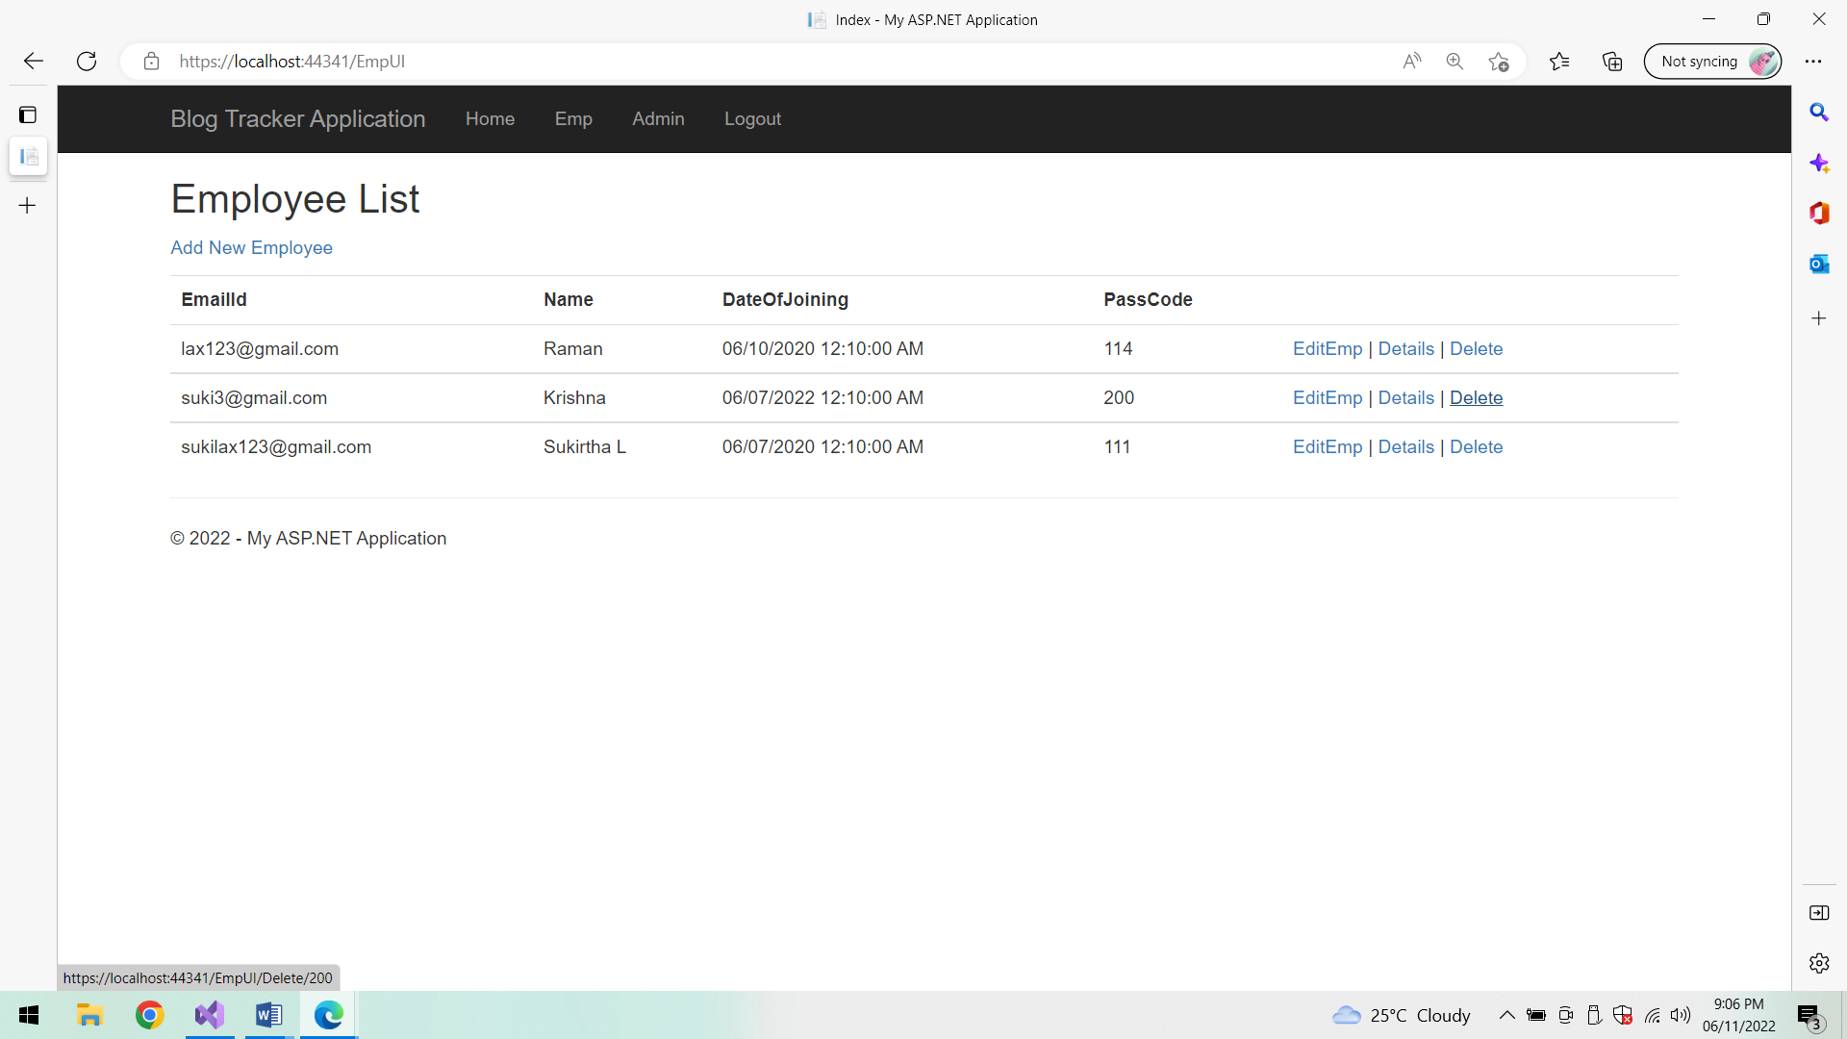

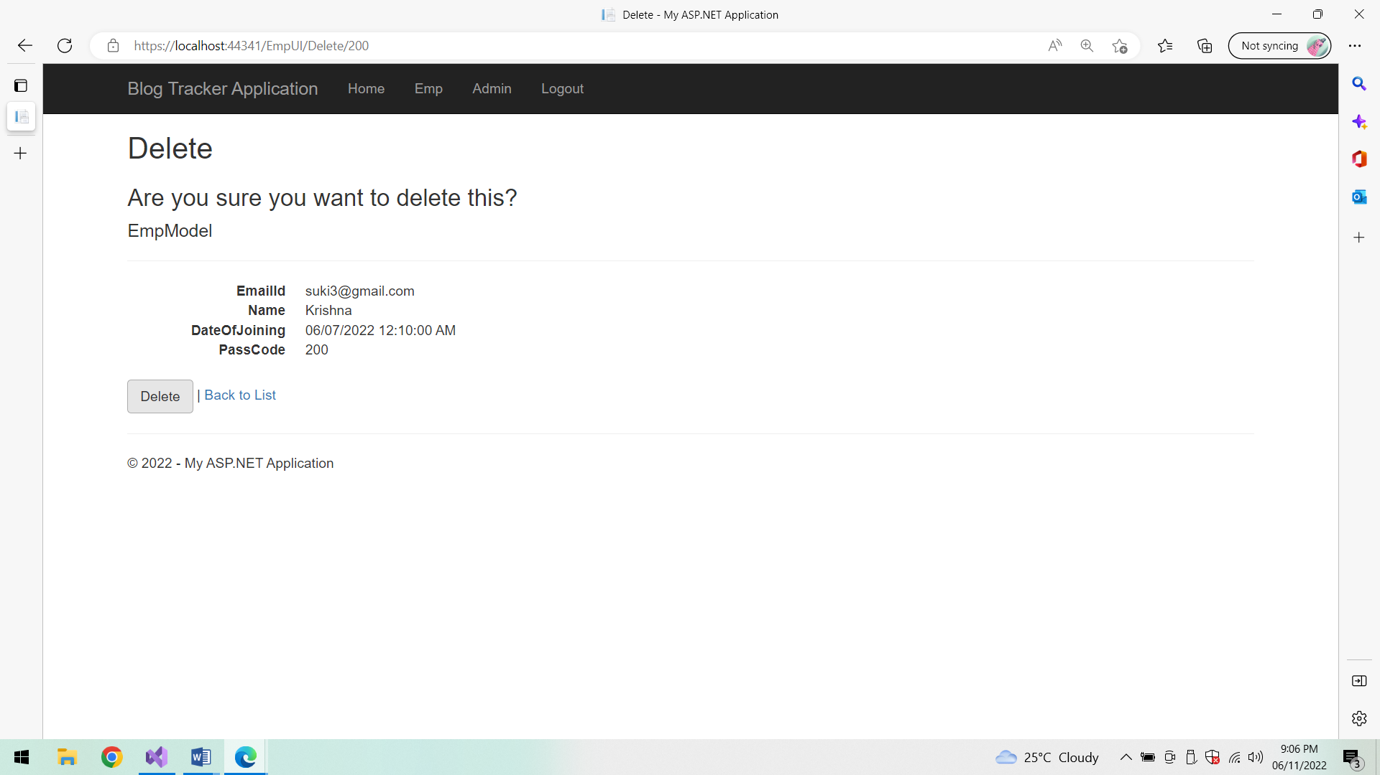

**After Deletion:**

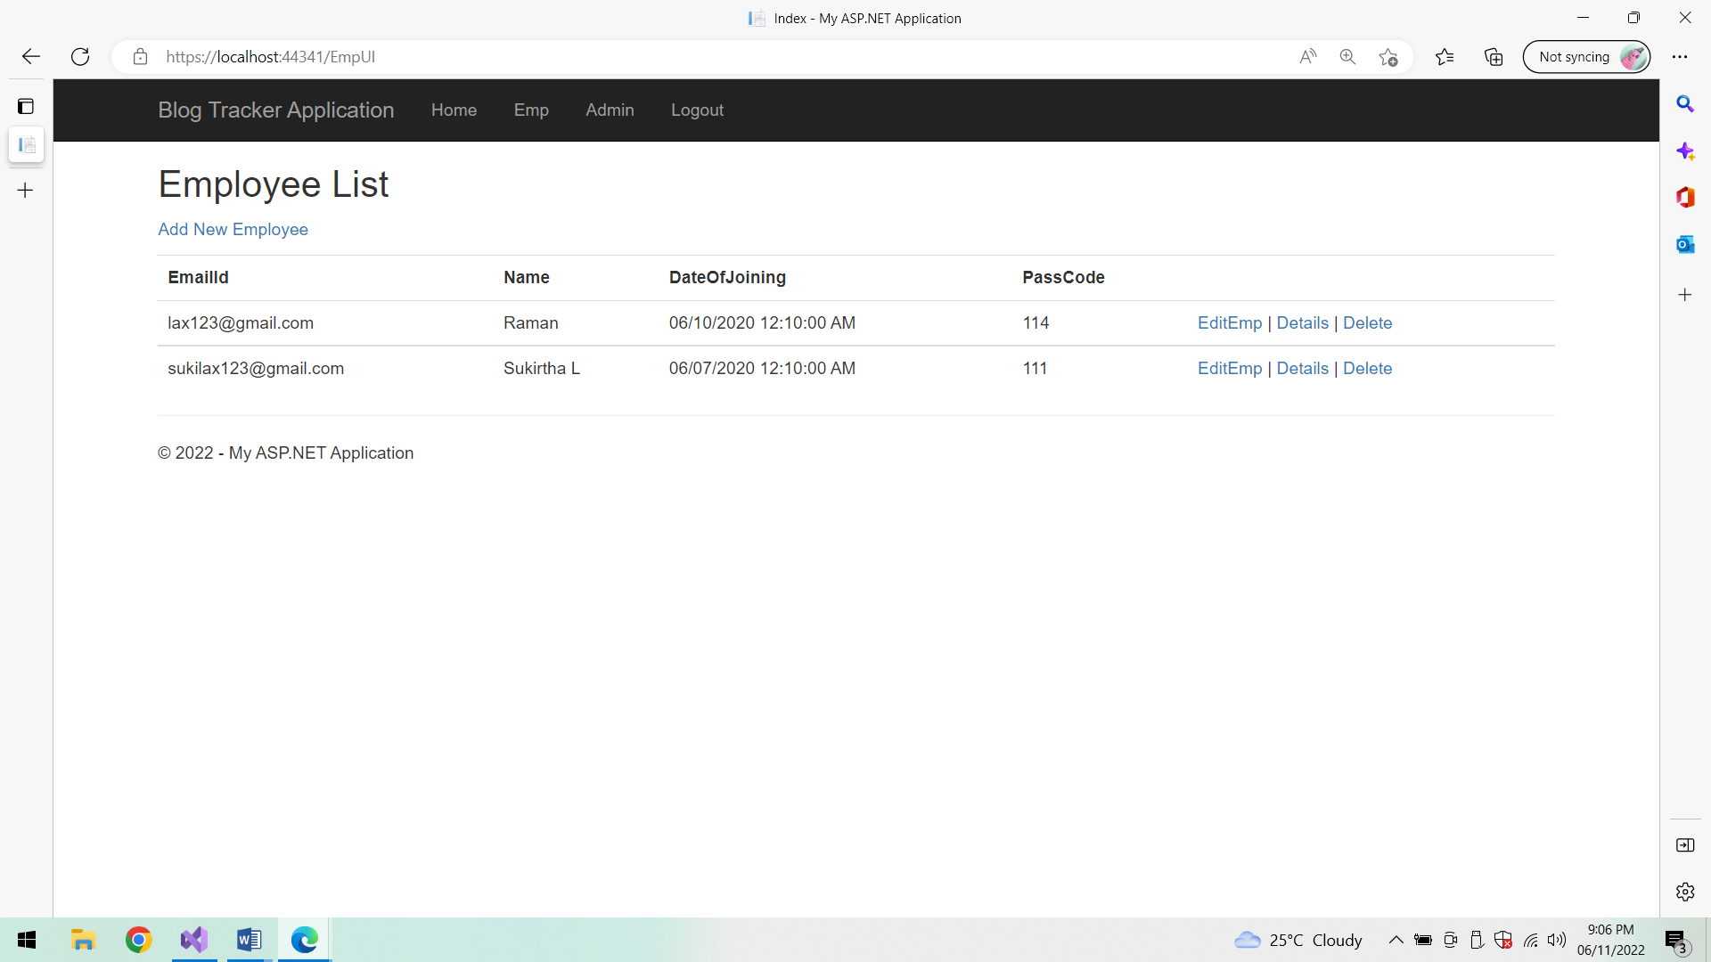

**Log out:**

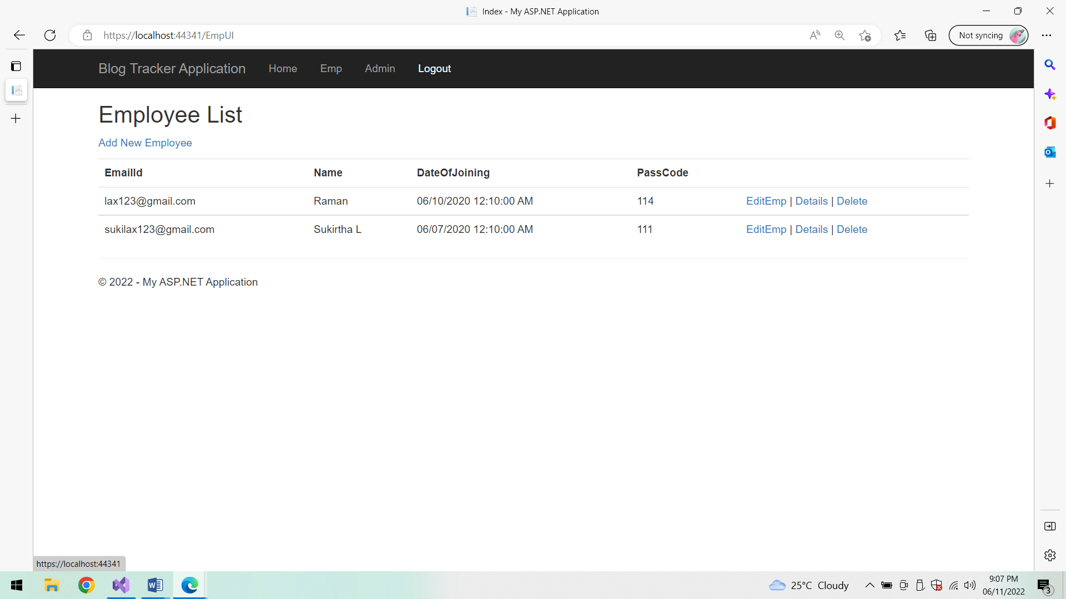

**Home Page:**

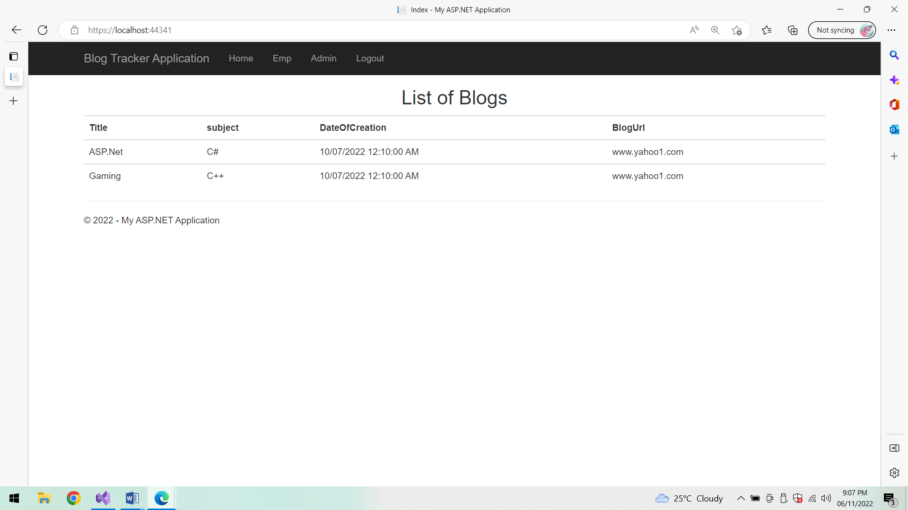

**Employee login:**

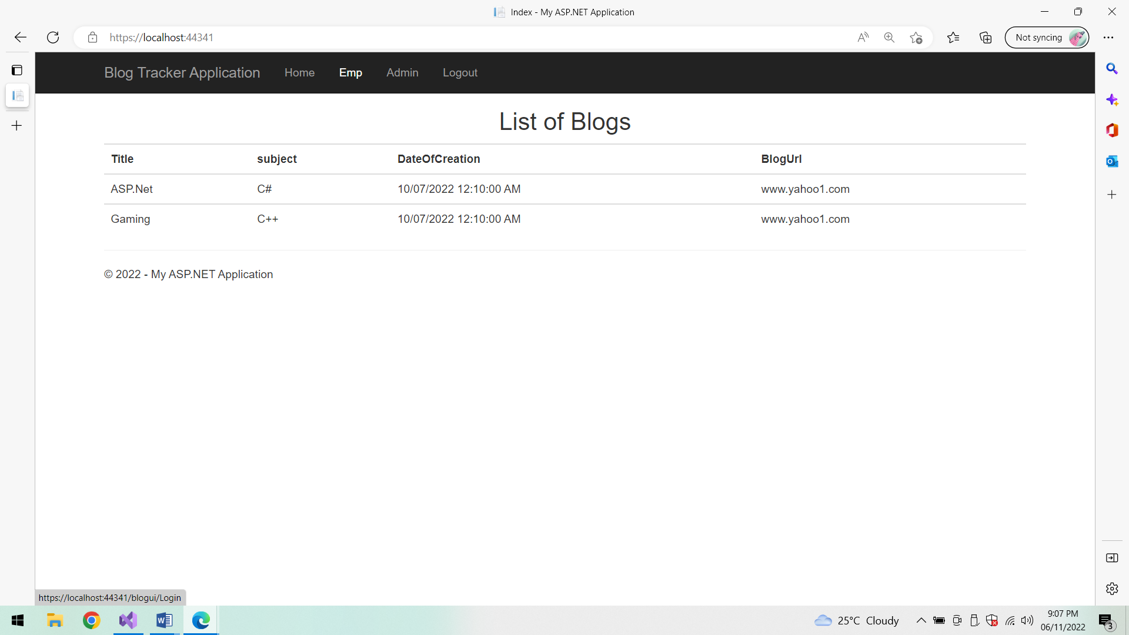

**Employee Login page:**

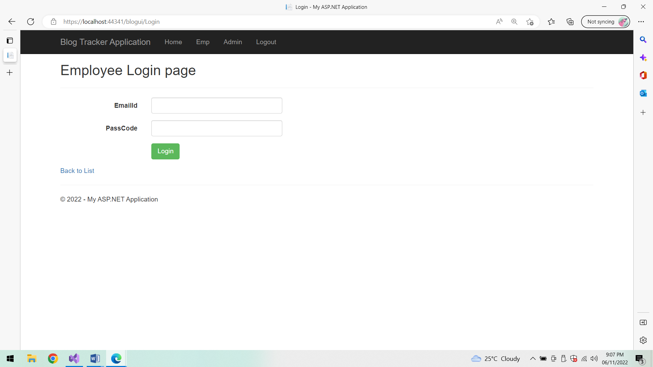

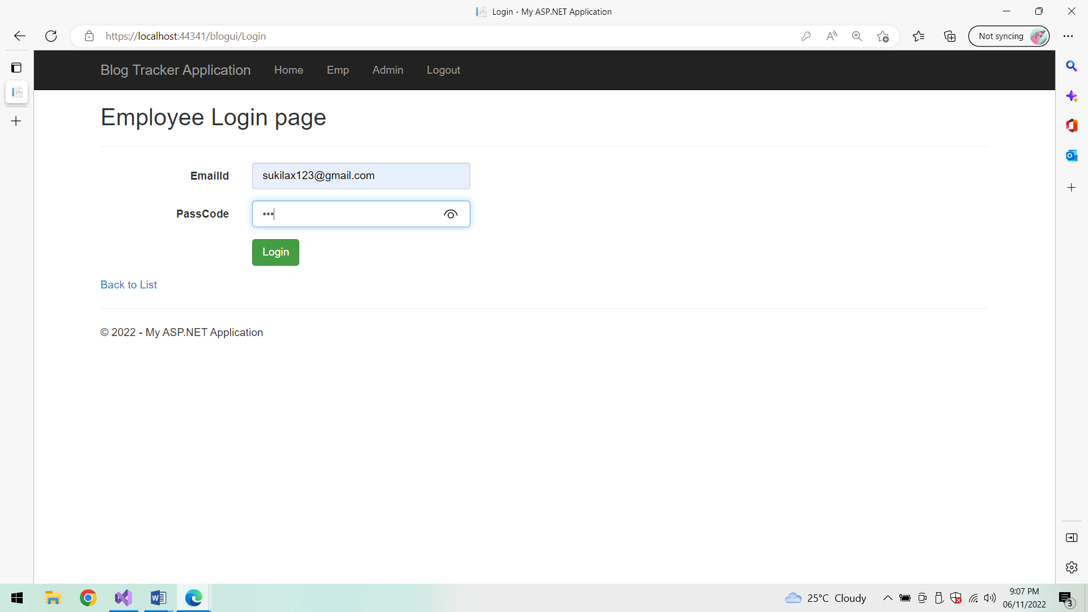

**List of Blogs:**

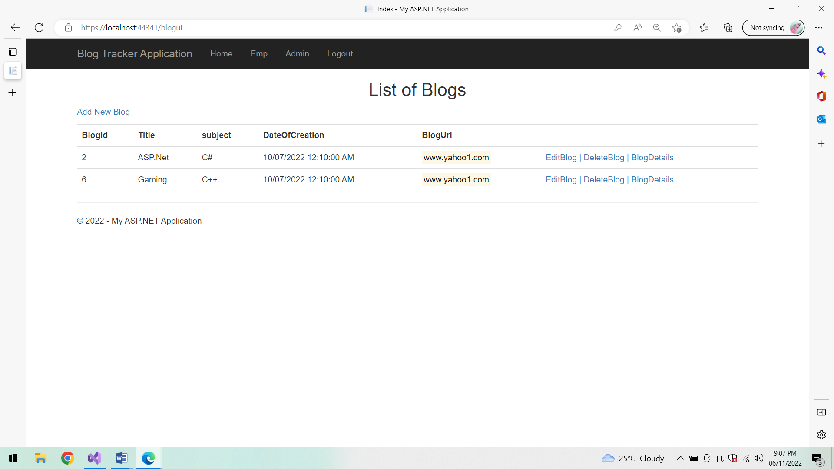

**Add Blog Details:**

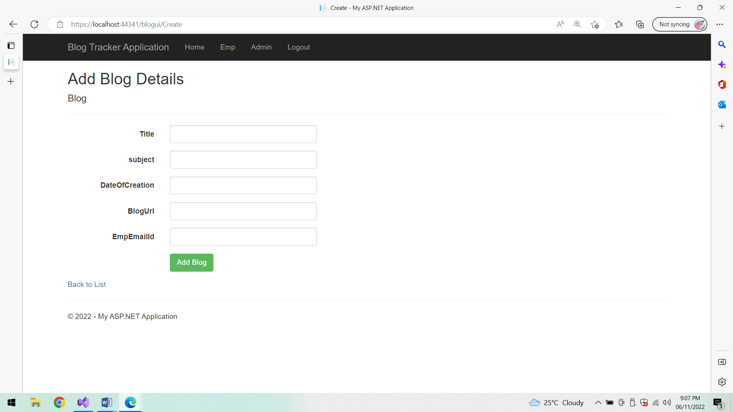

**After Adding Blog Details:**

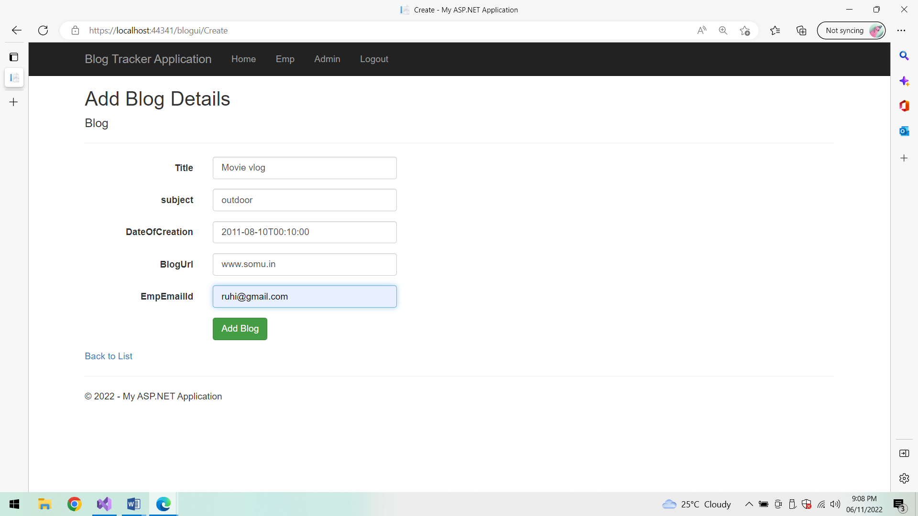

**List of Blogs:**

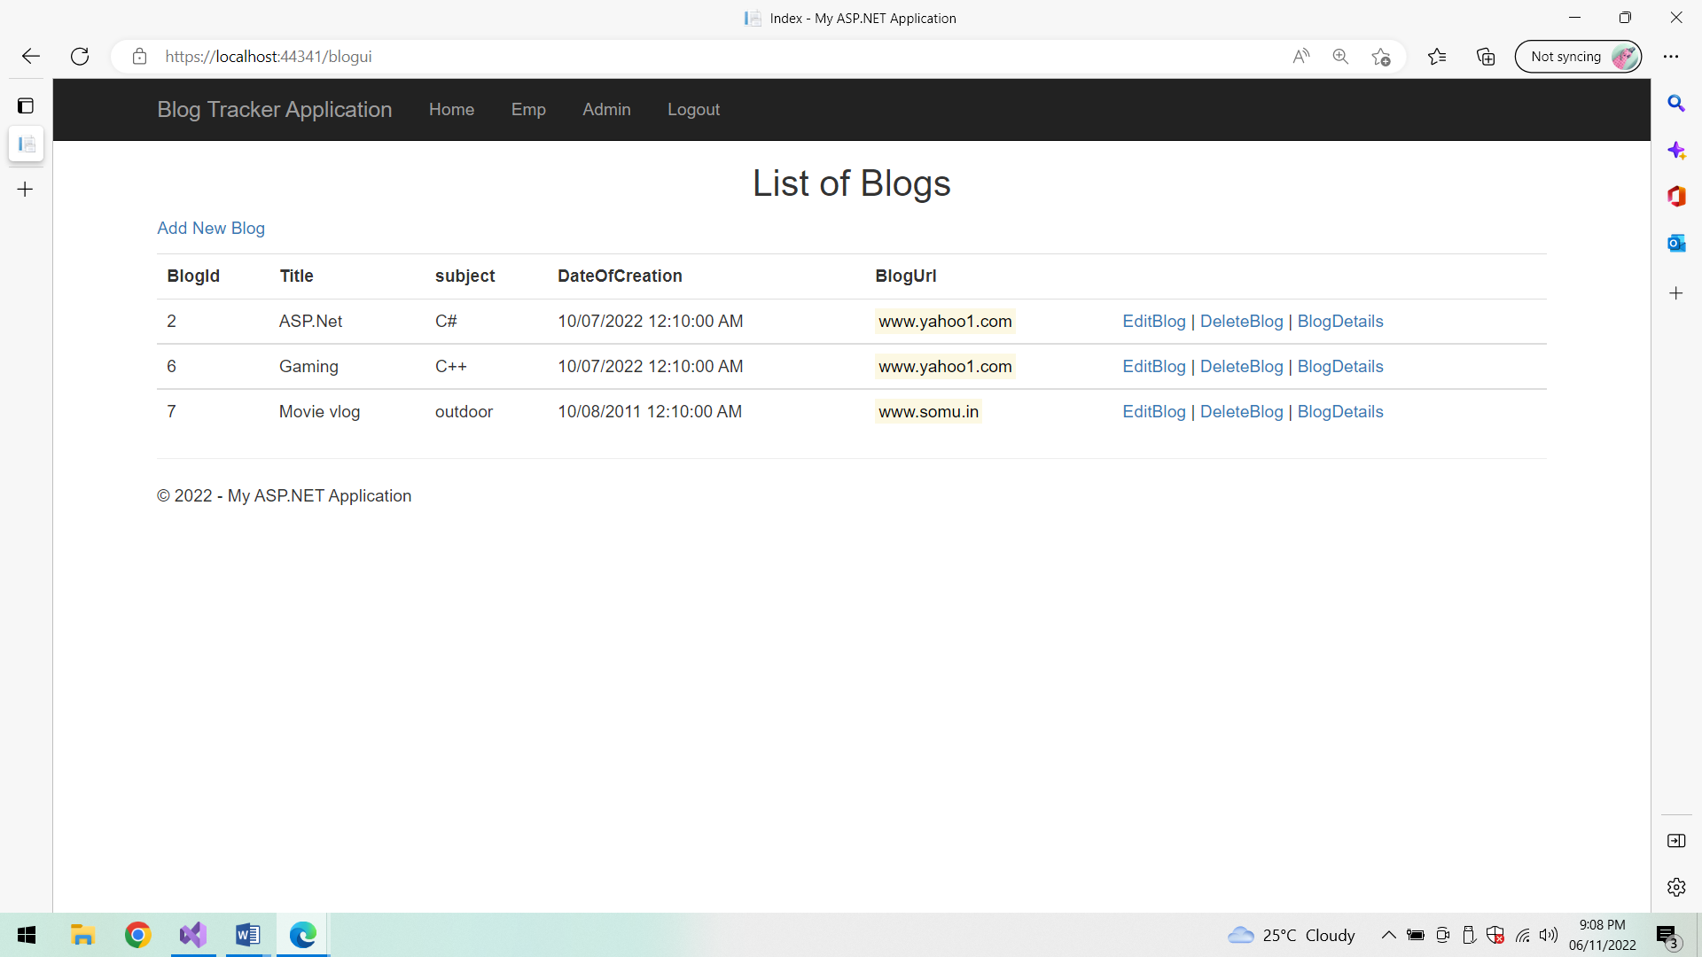

**Edit Blog details:**

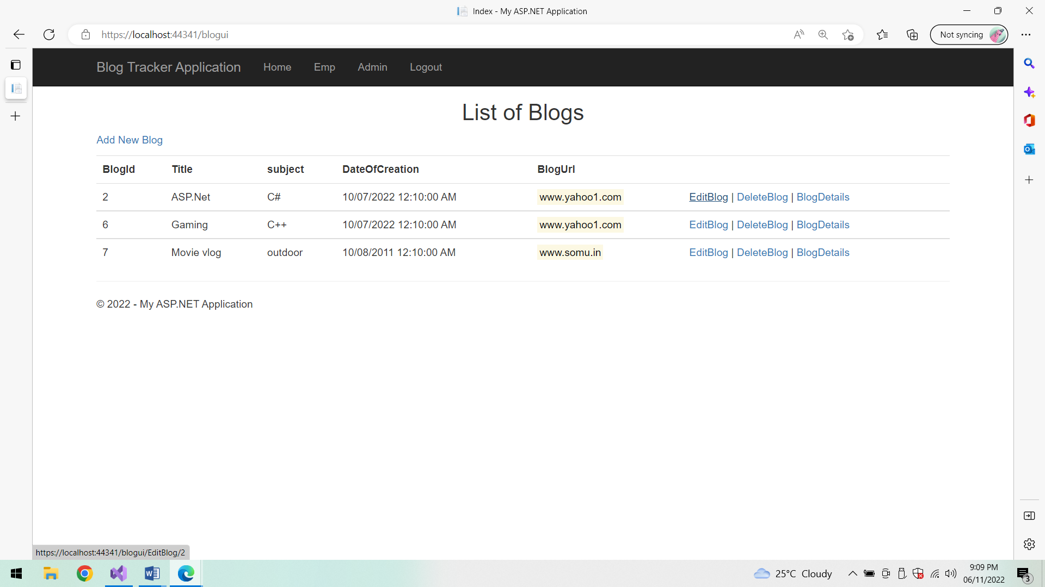

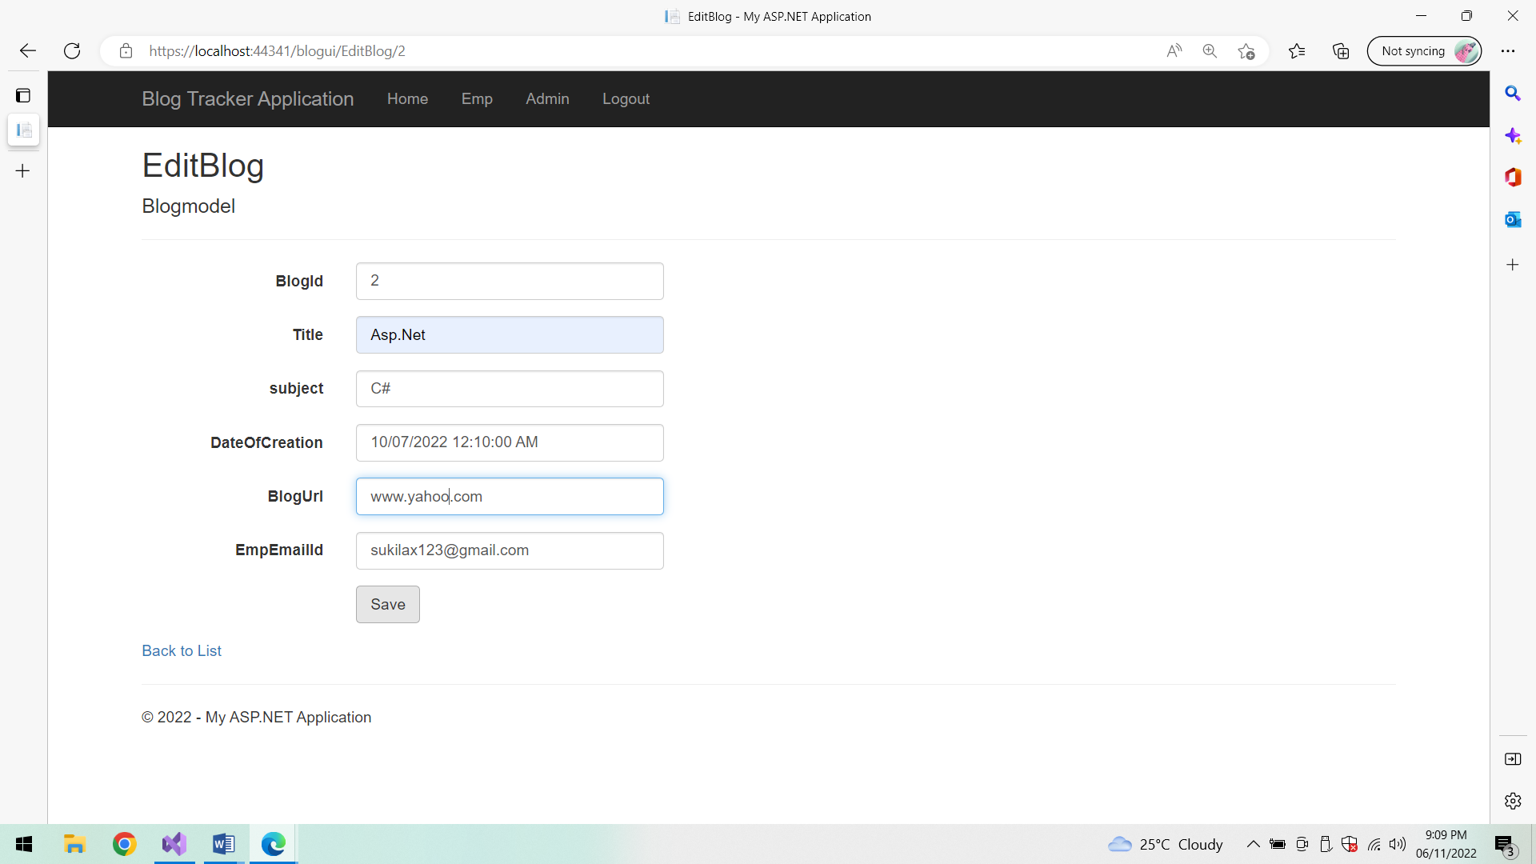

**After Editing Blog details:**

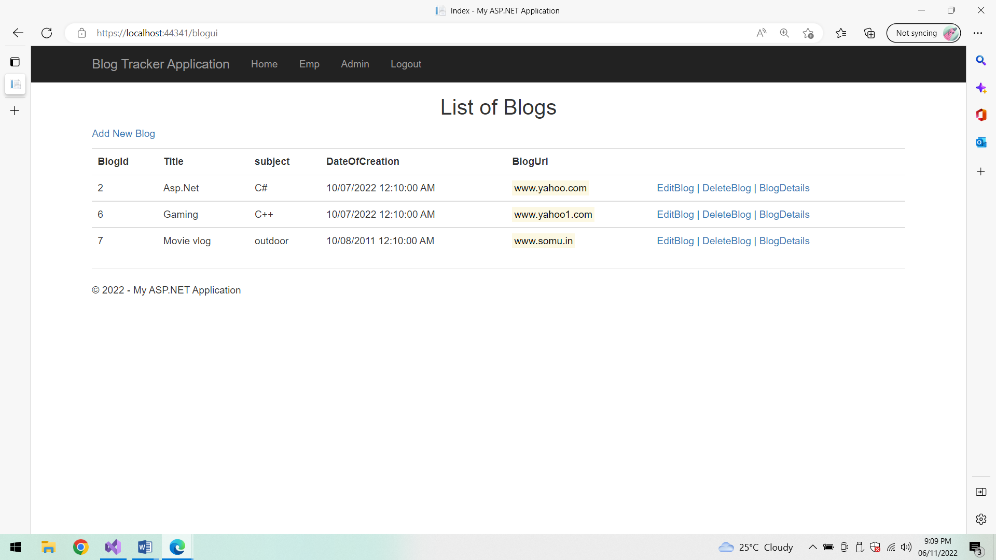

**Blog Details:**

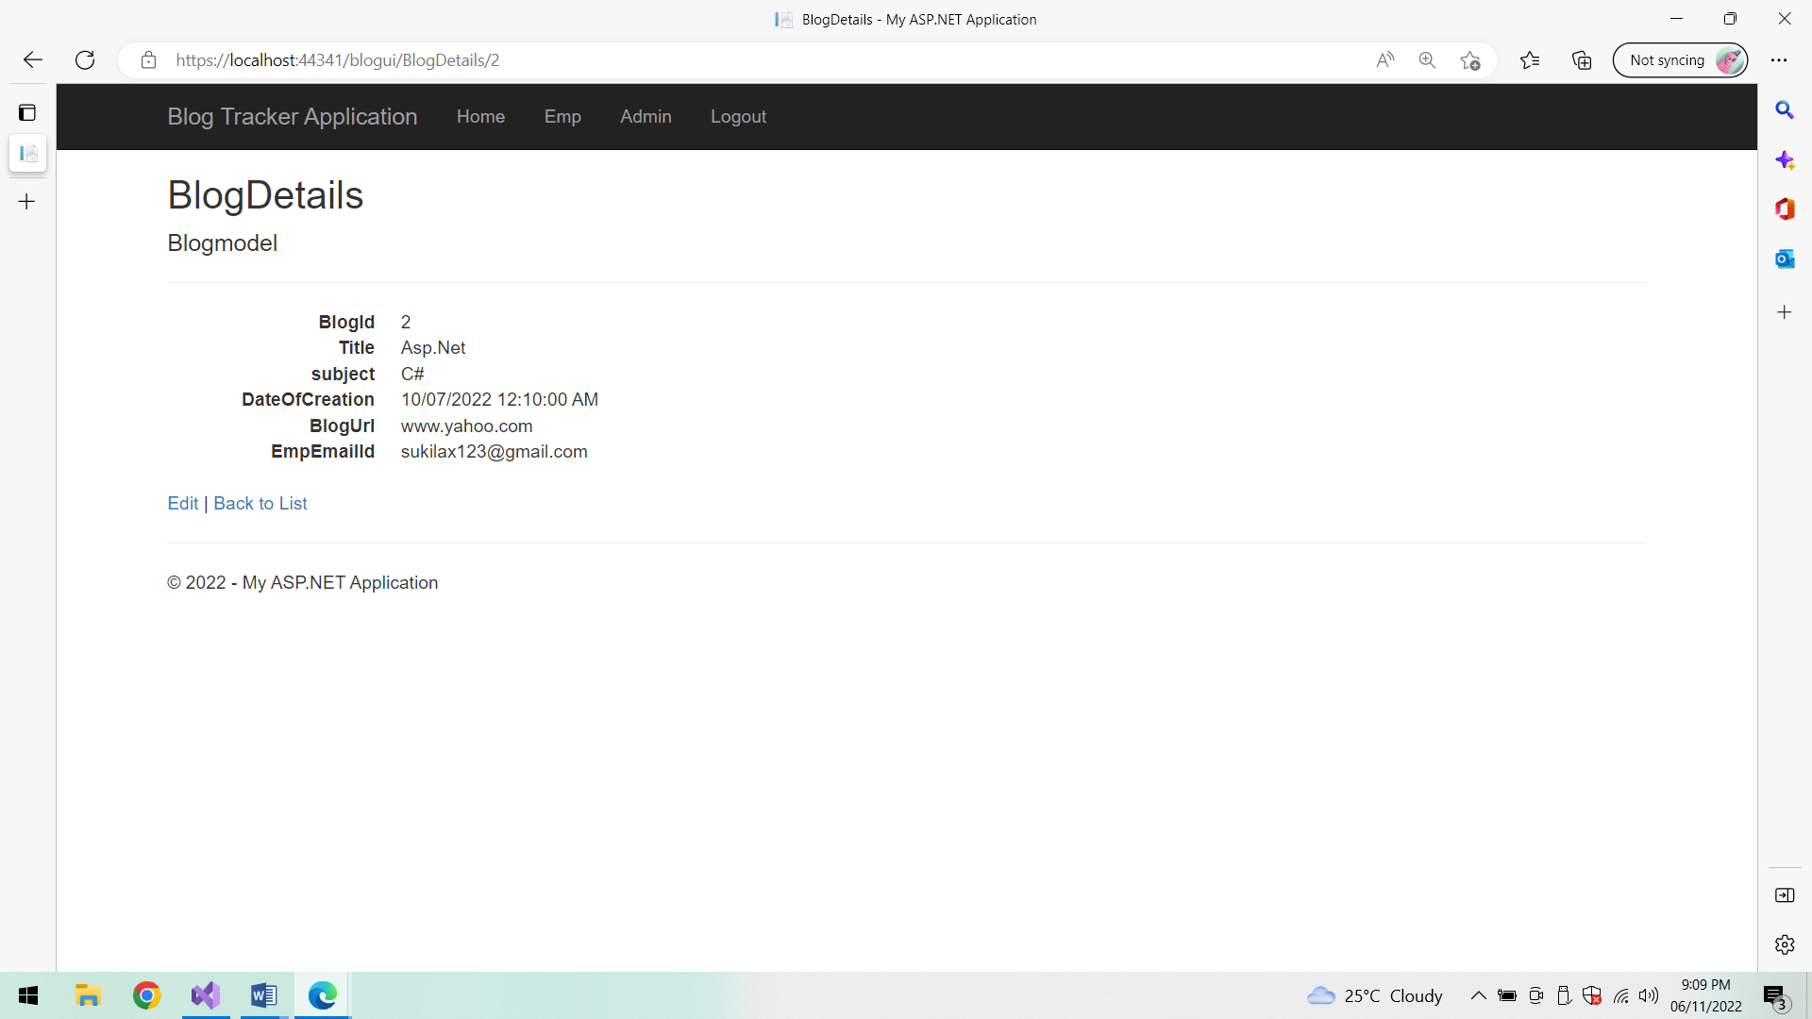

**Edit details:**

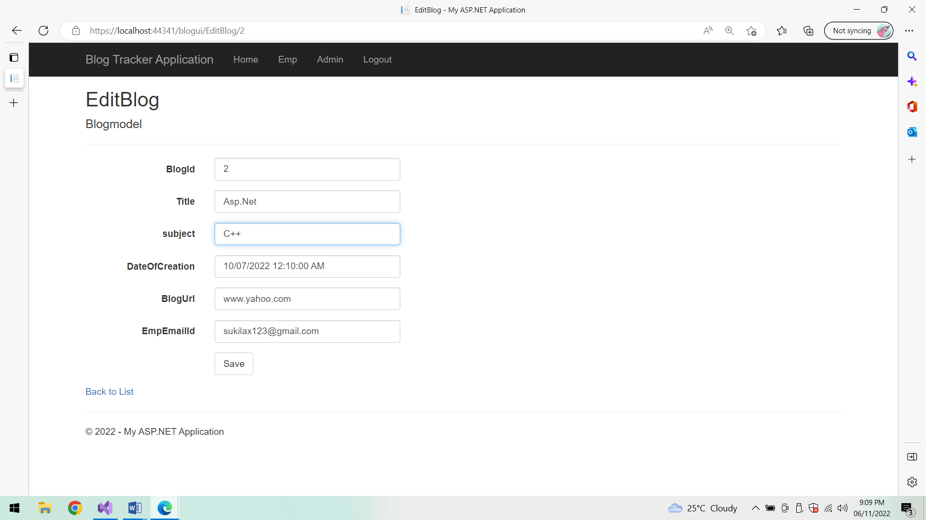

**List of Blogs:**

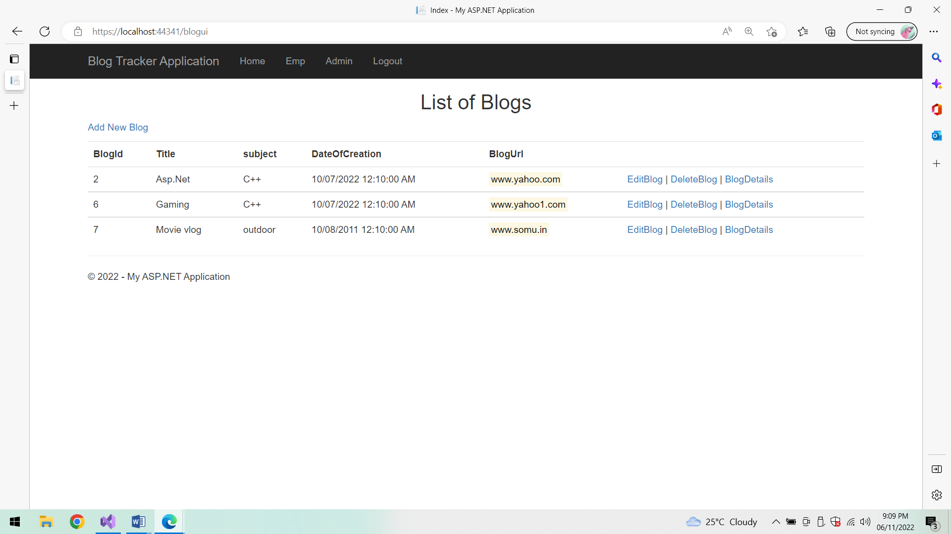

**Delete Blog:**

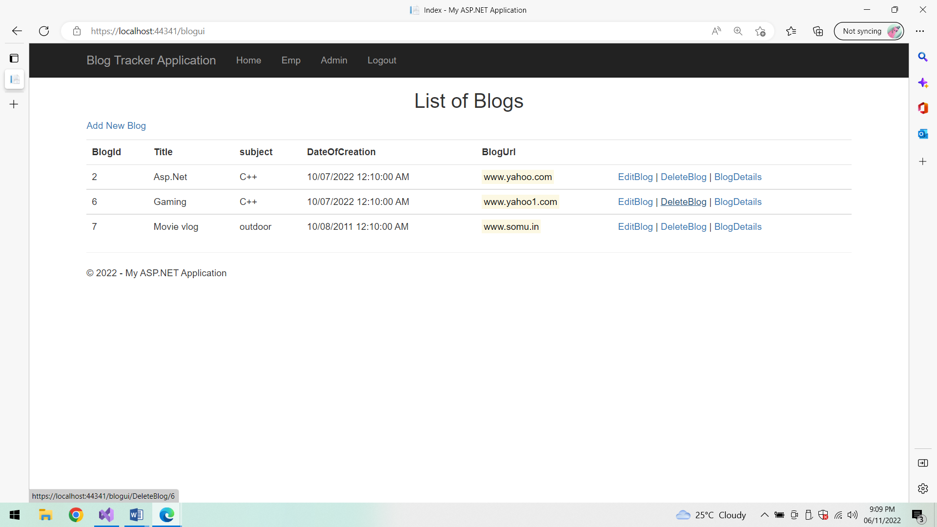

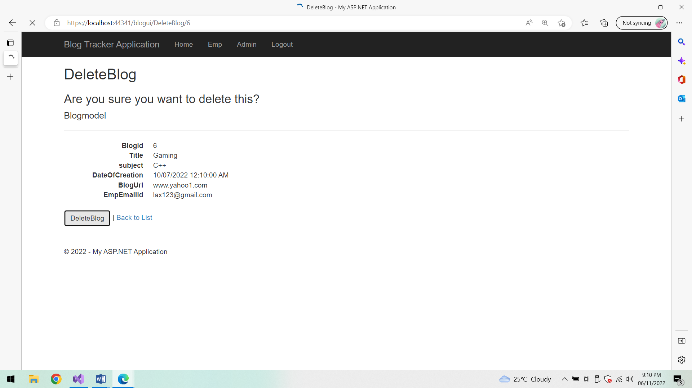

**After deletion list of Blogs:**

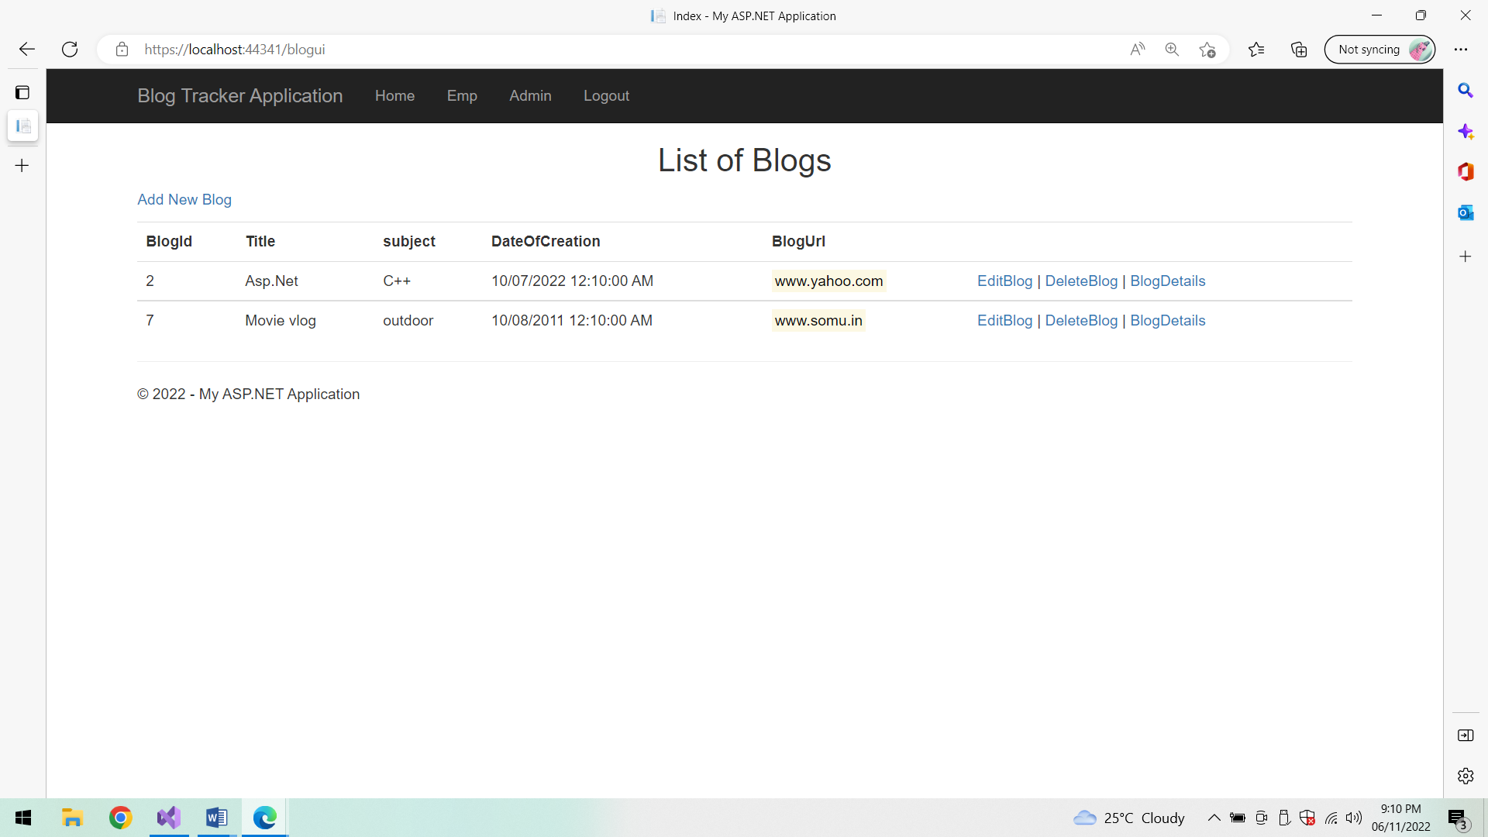

**Log out:**

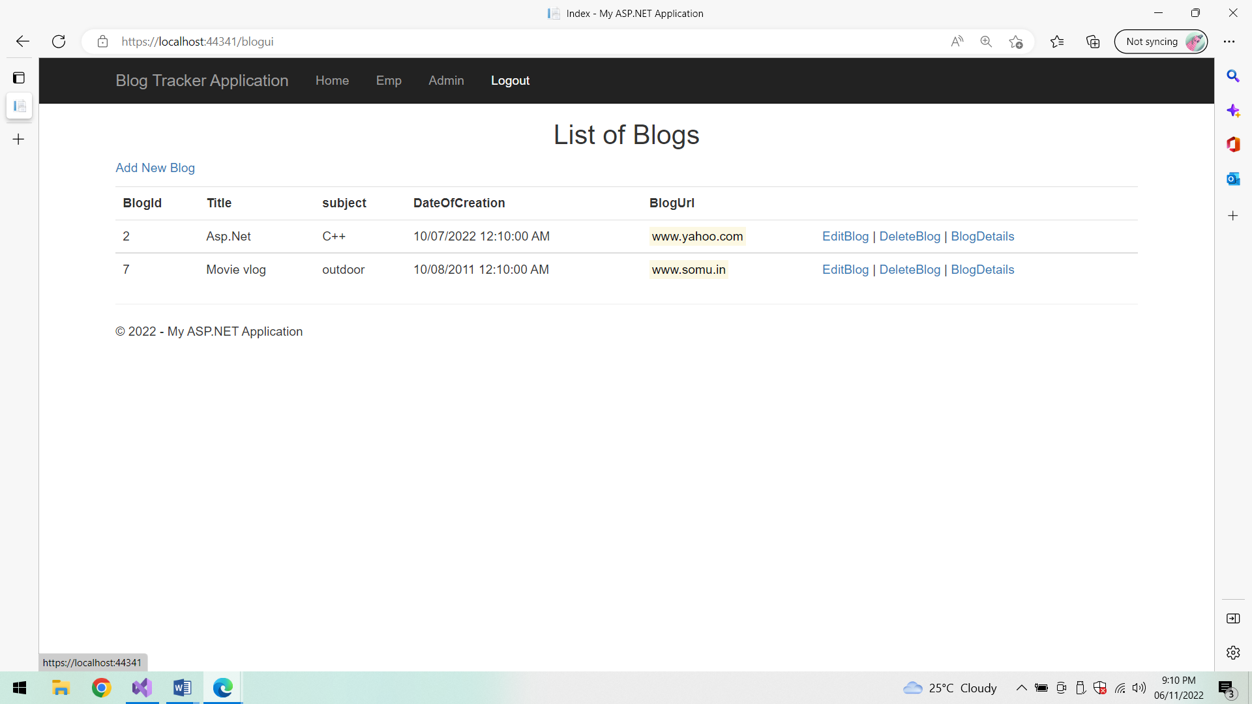

**Home Page:**

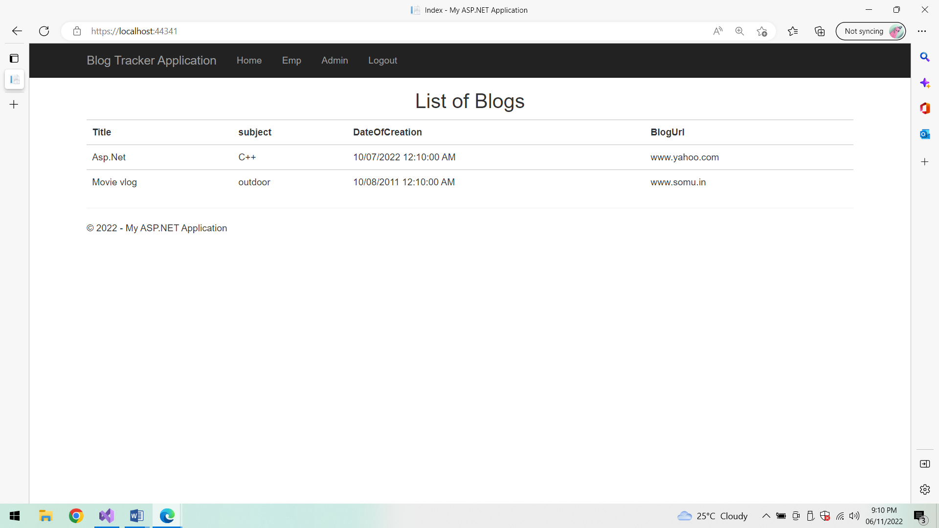

**Unit Testing:**

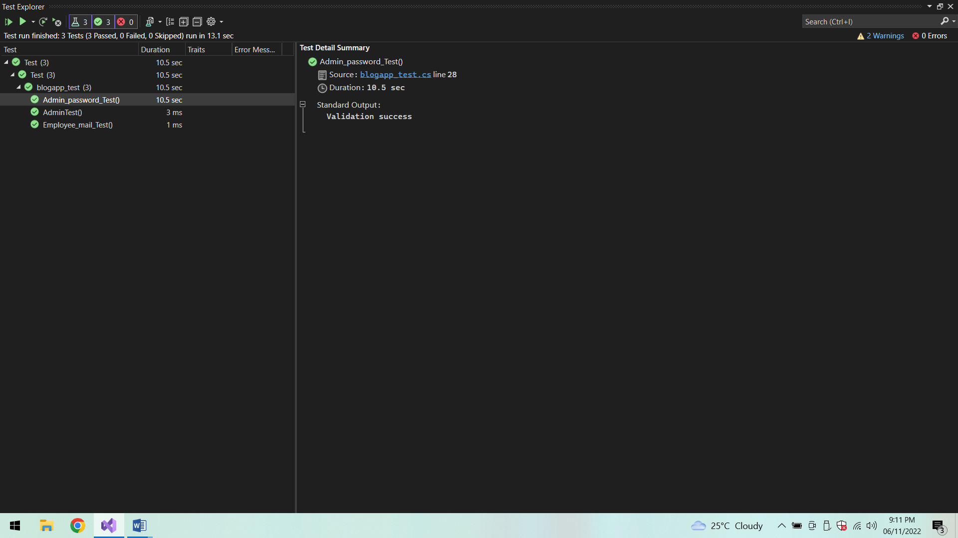

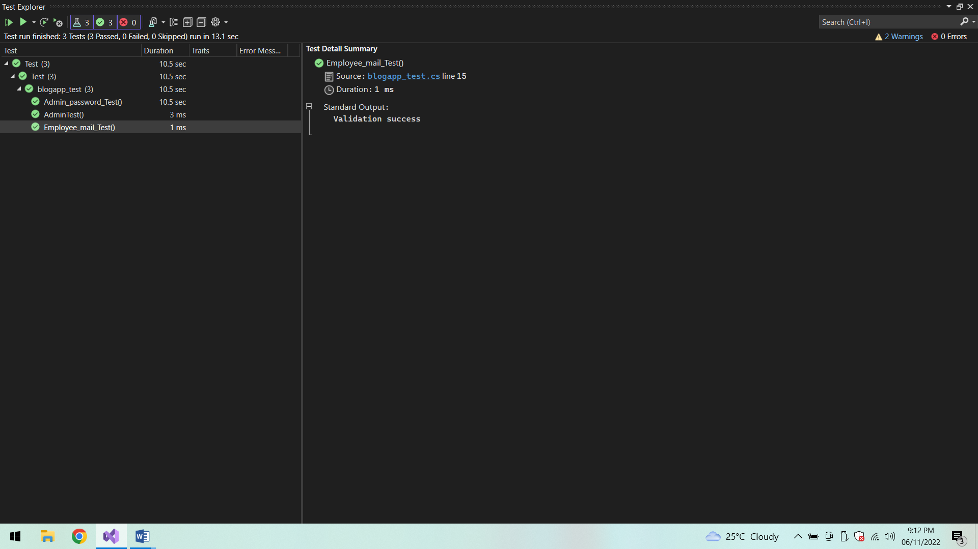

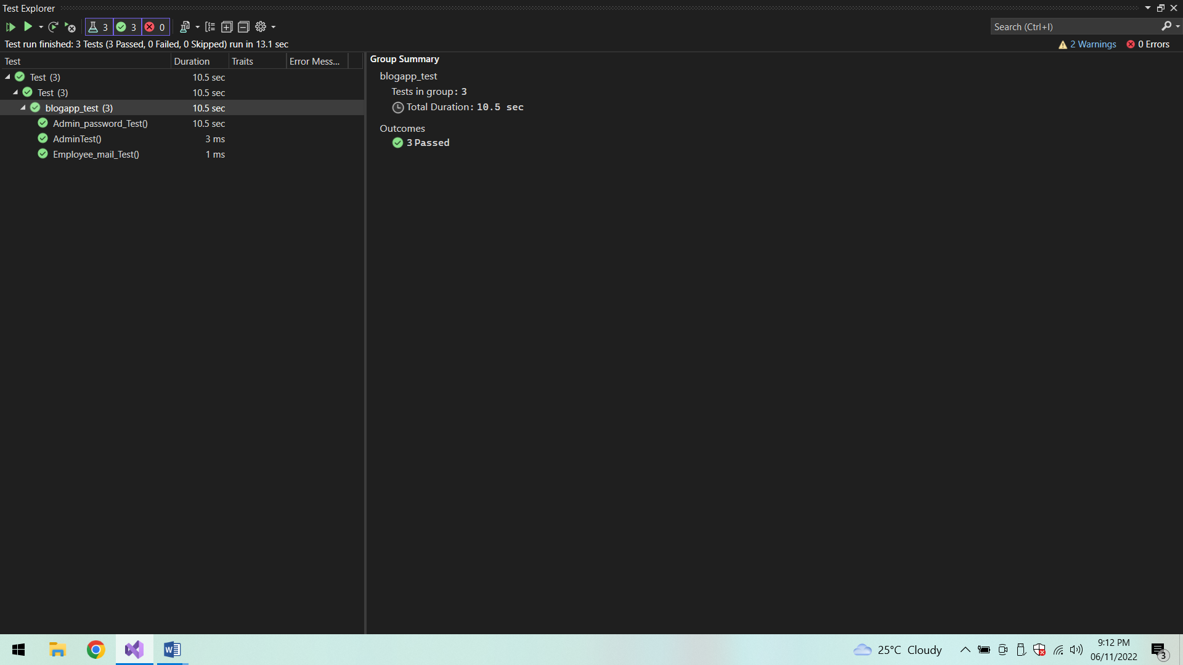

**Azure database:**

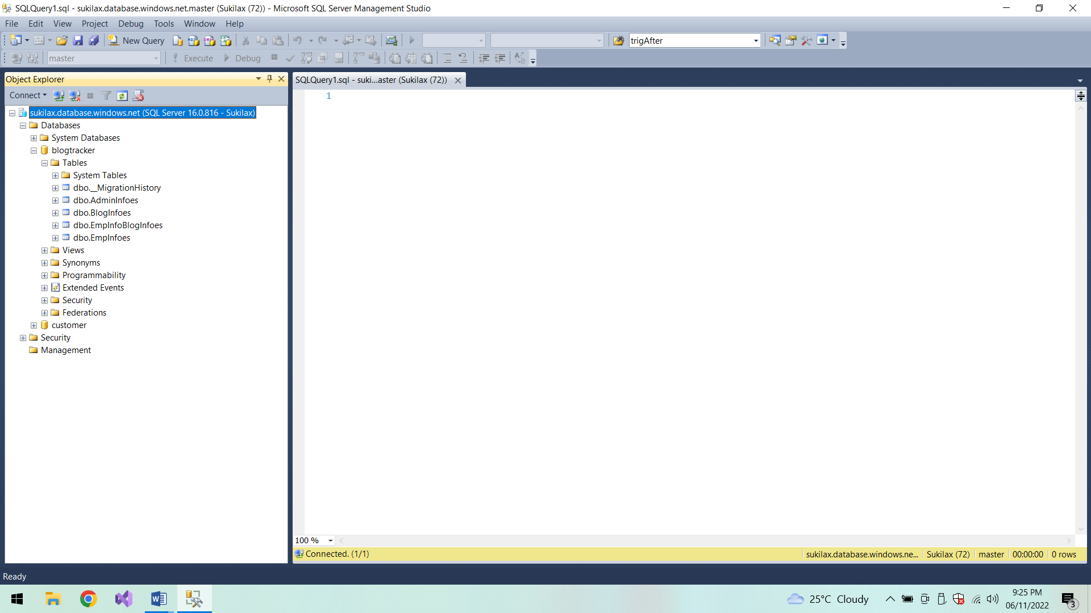

**Admin Info:**

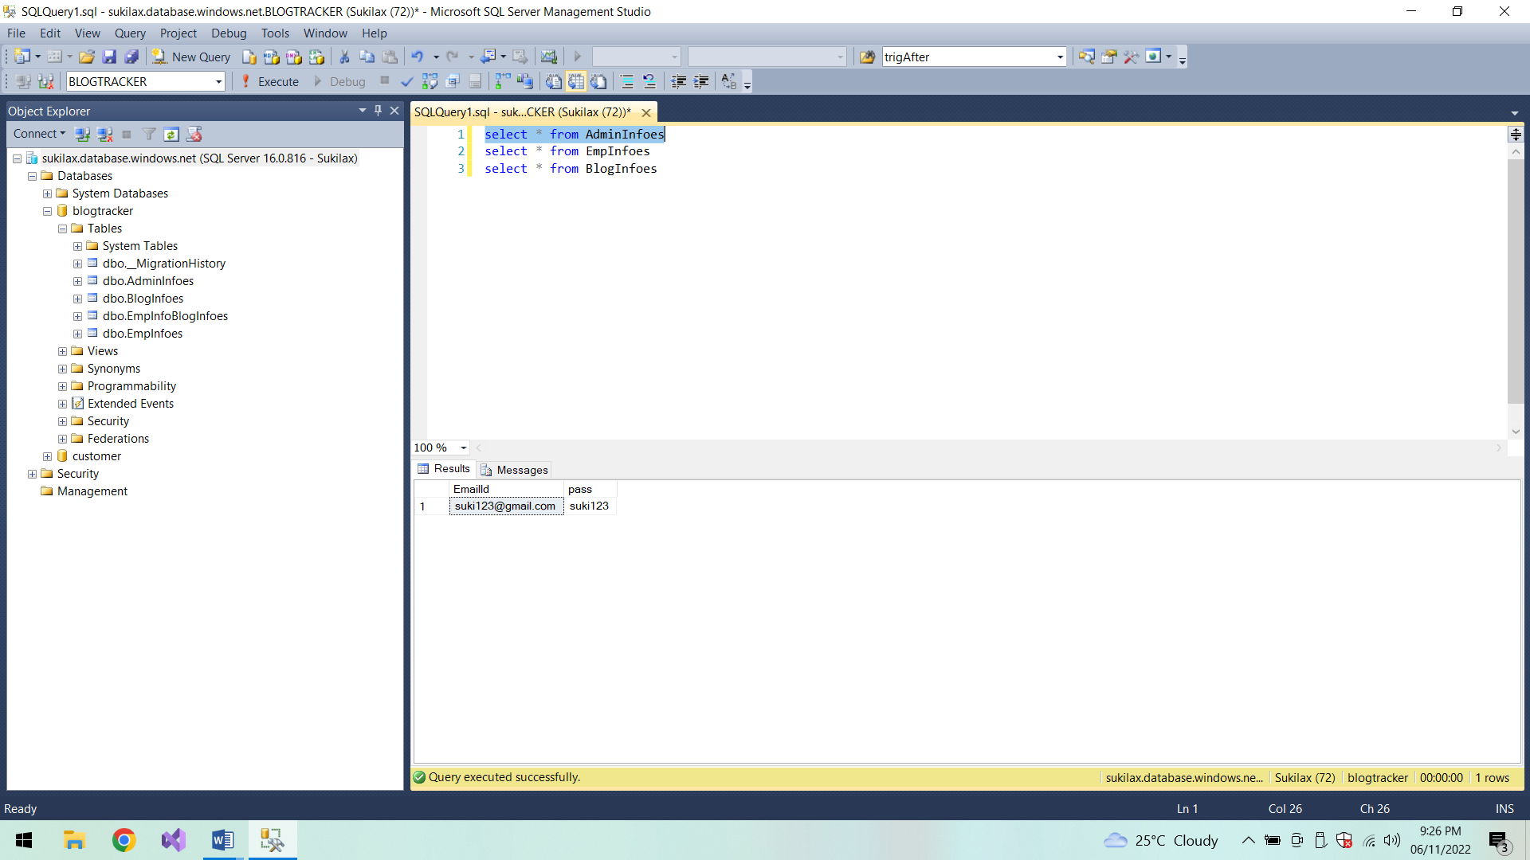

**Employee Info:**

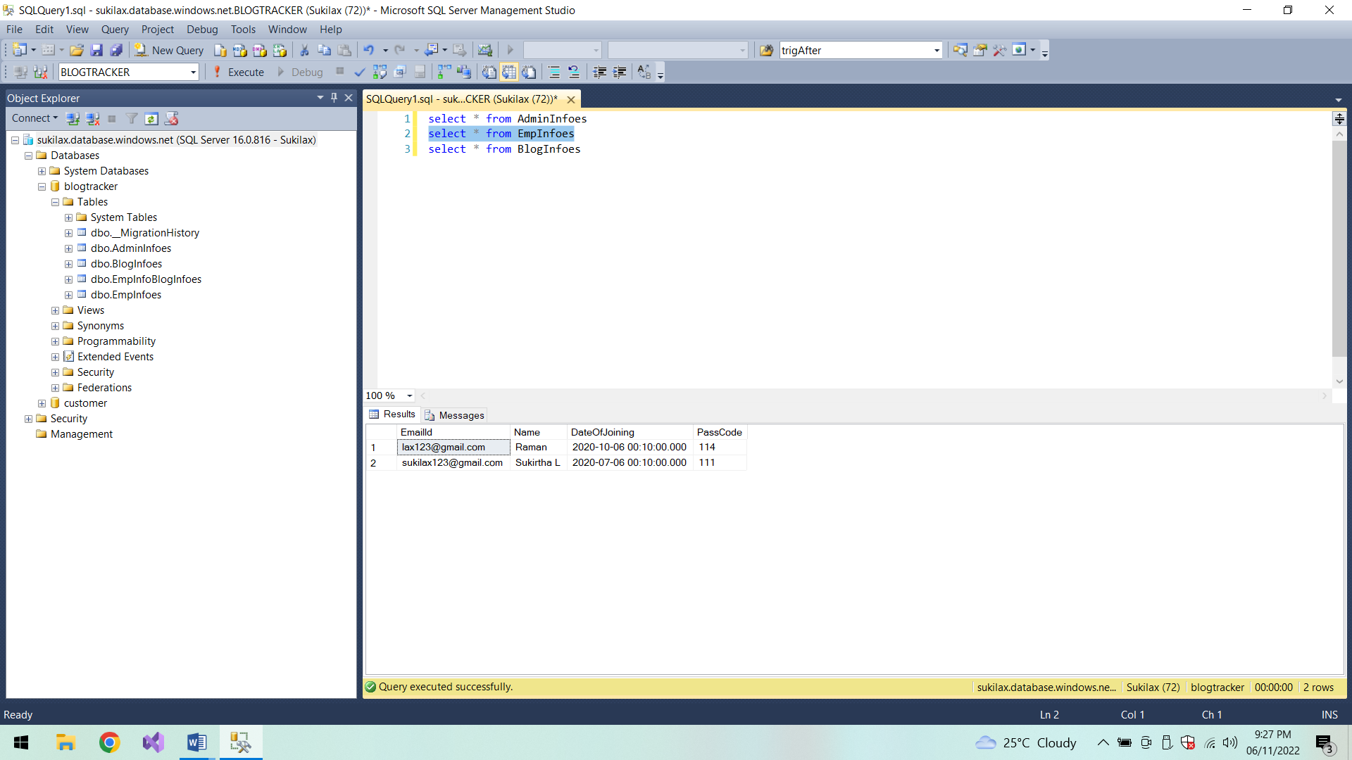

**Blog Info:**

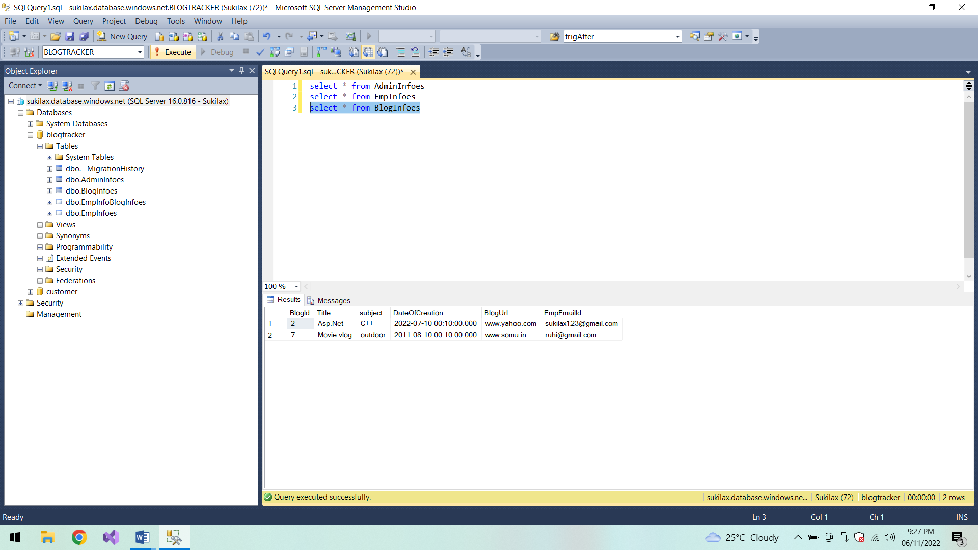

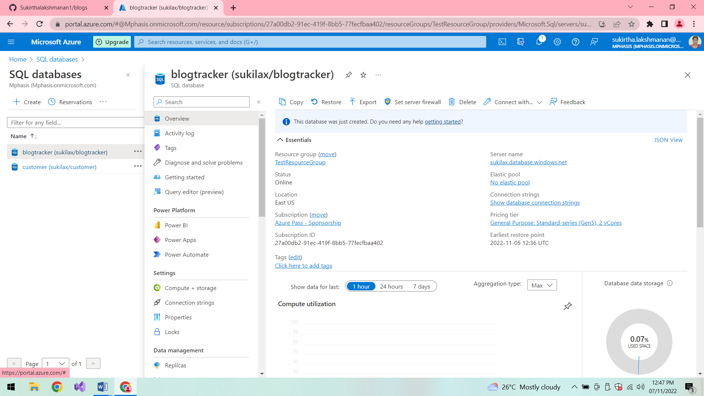

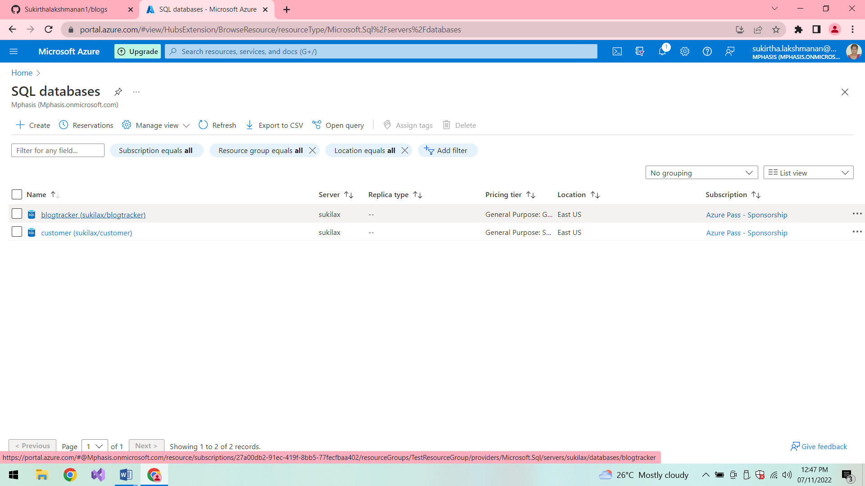

**Postman Output:**

**GET:**

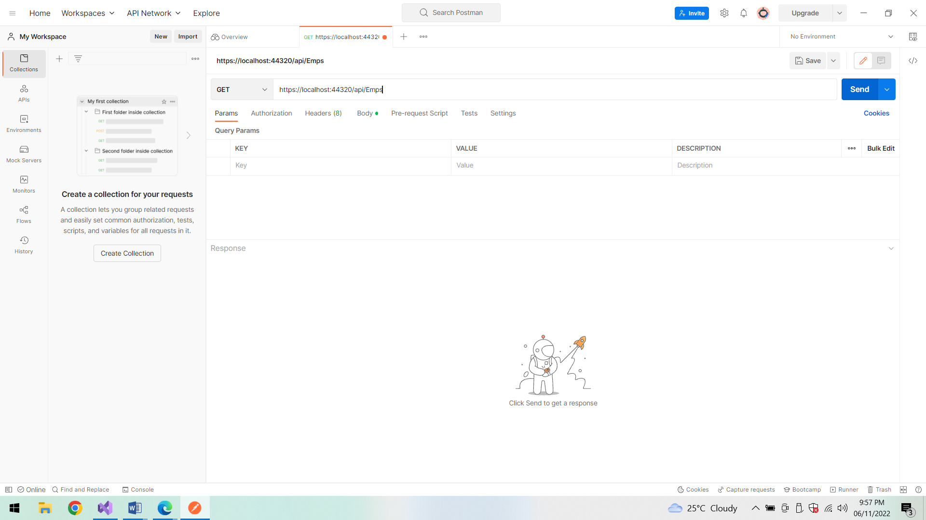

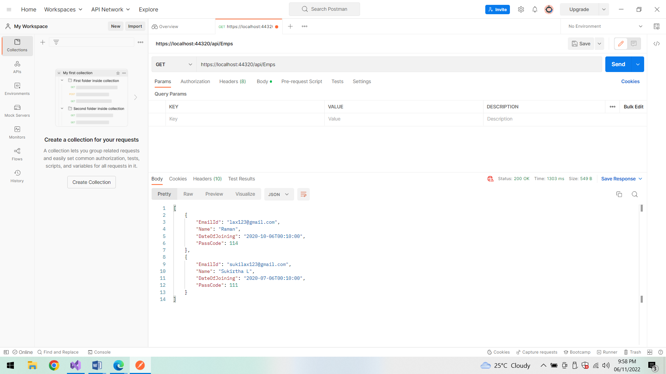

**POST:**

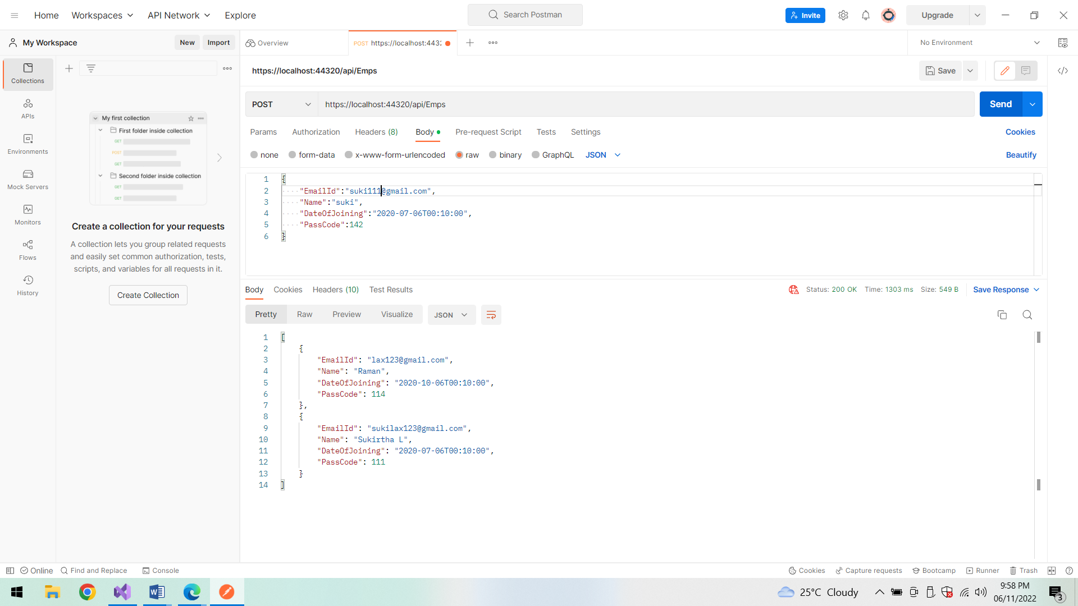

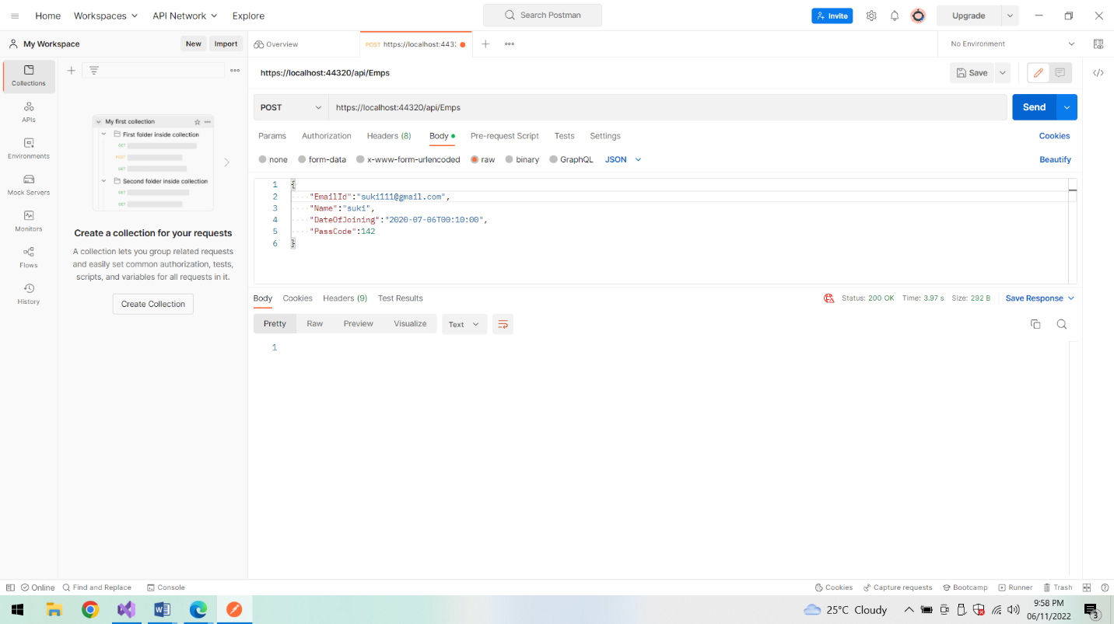

**GET:**

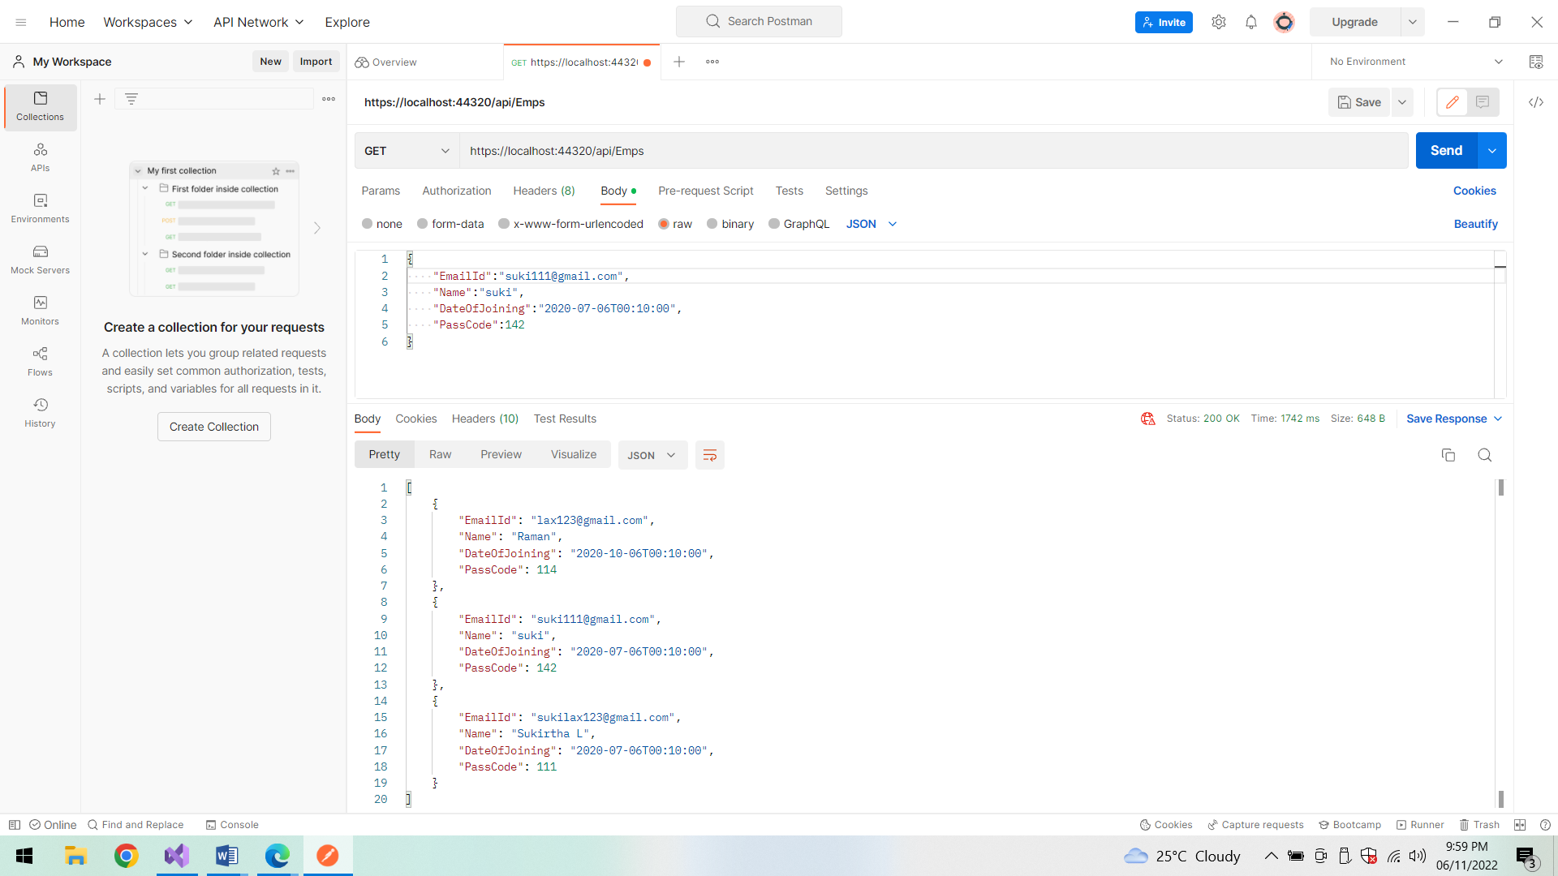

**PUT method:**

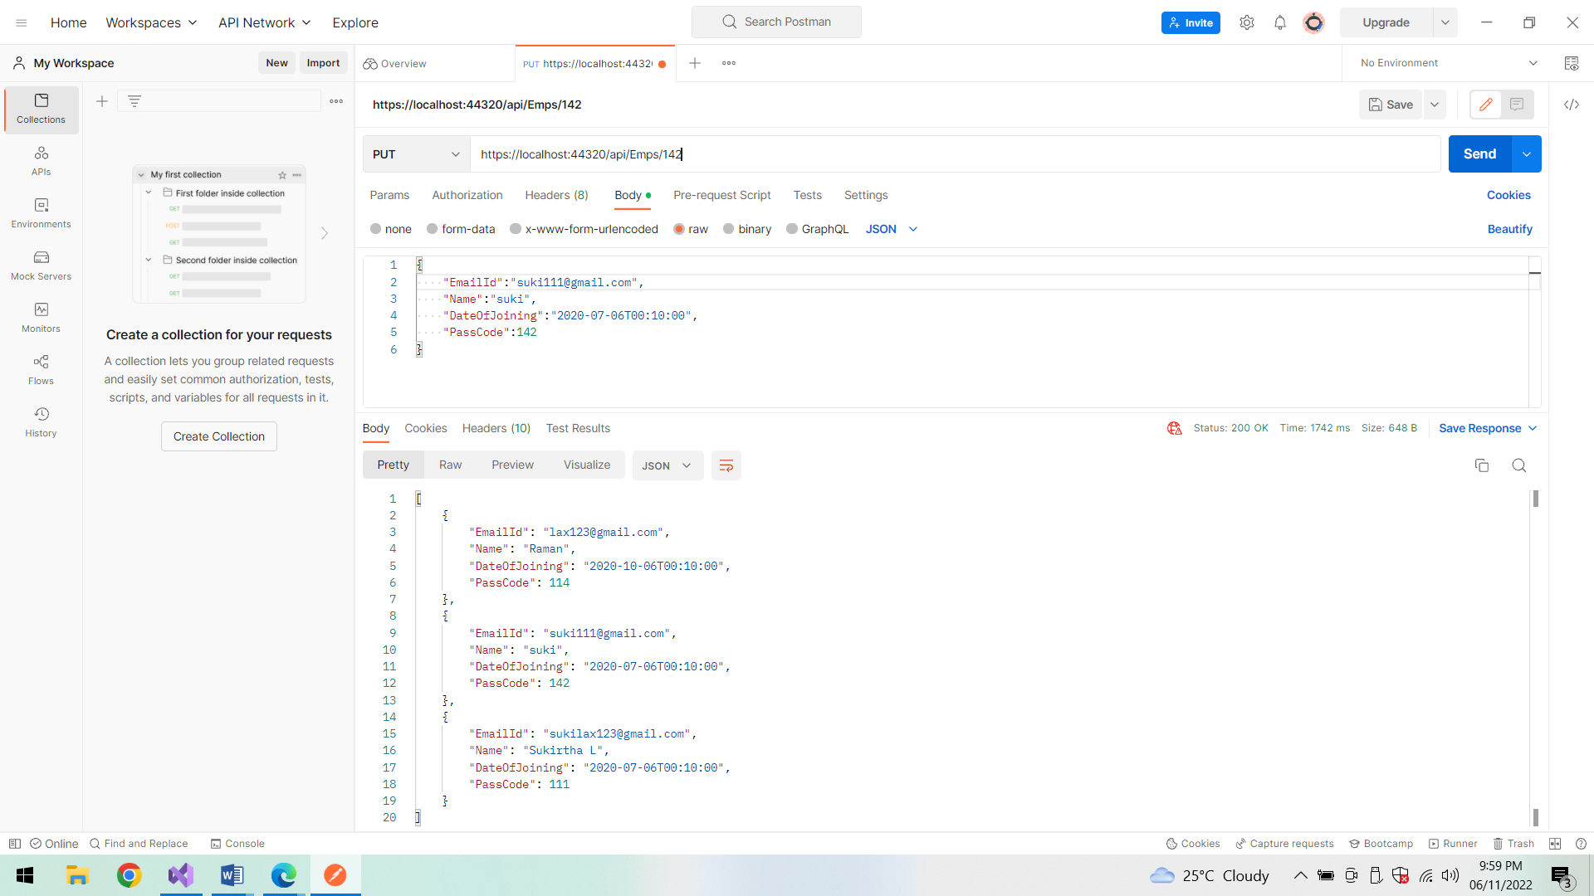

**Success status:**

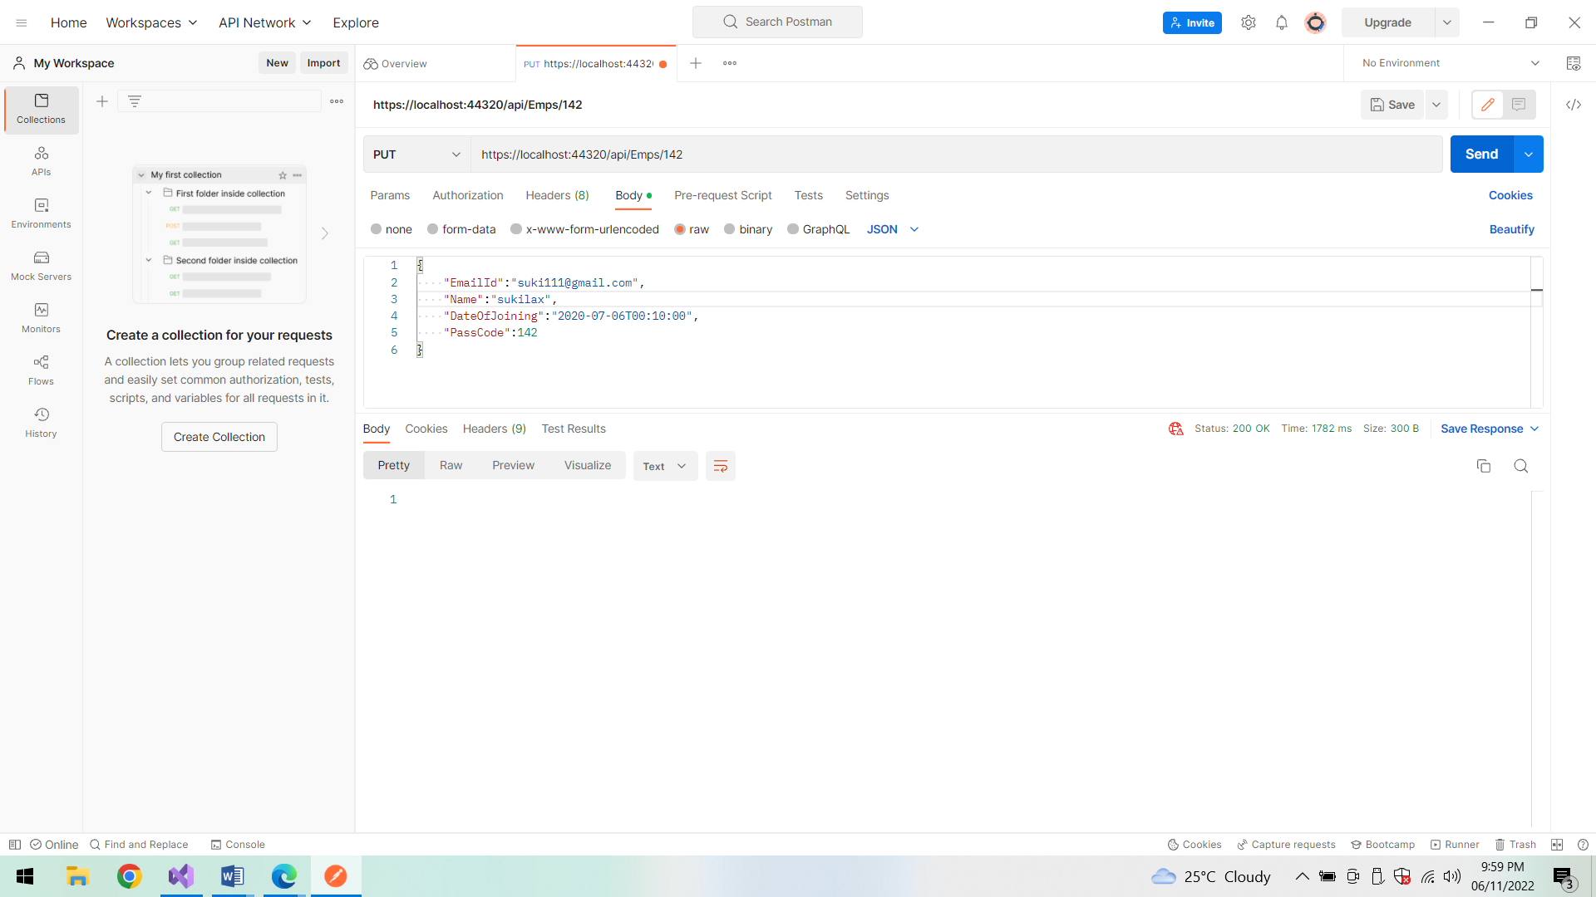

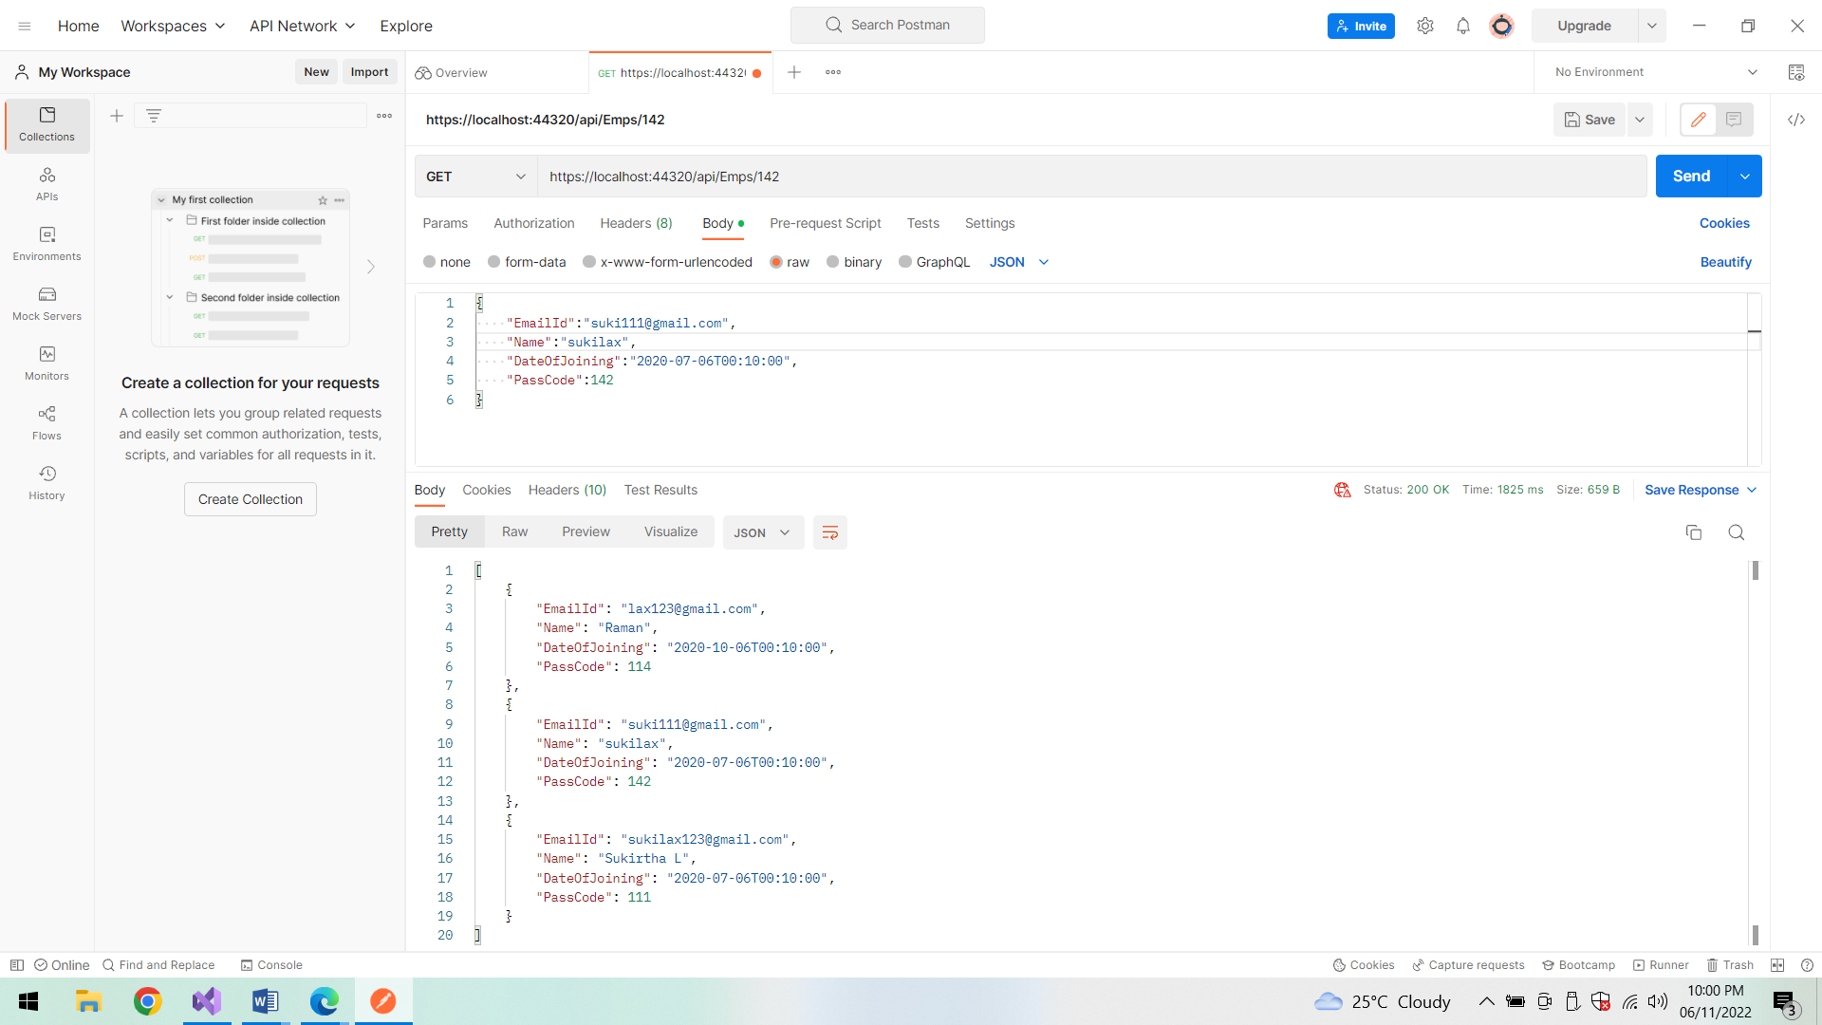

**Delete method:**

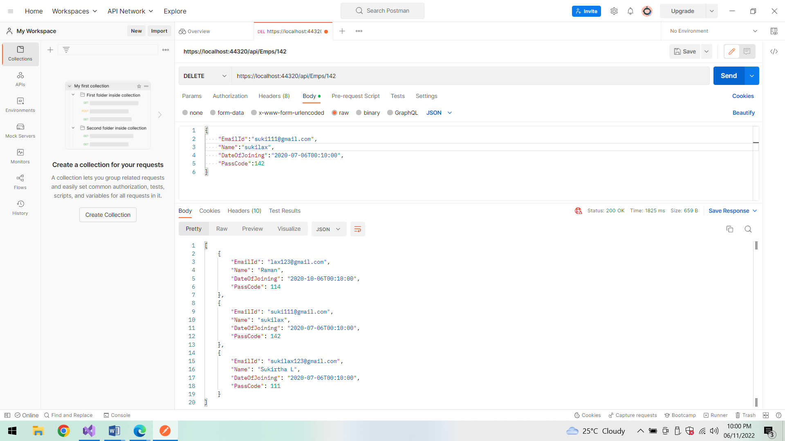

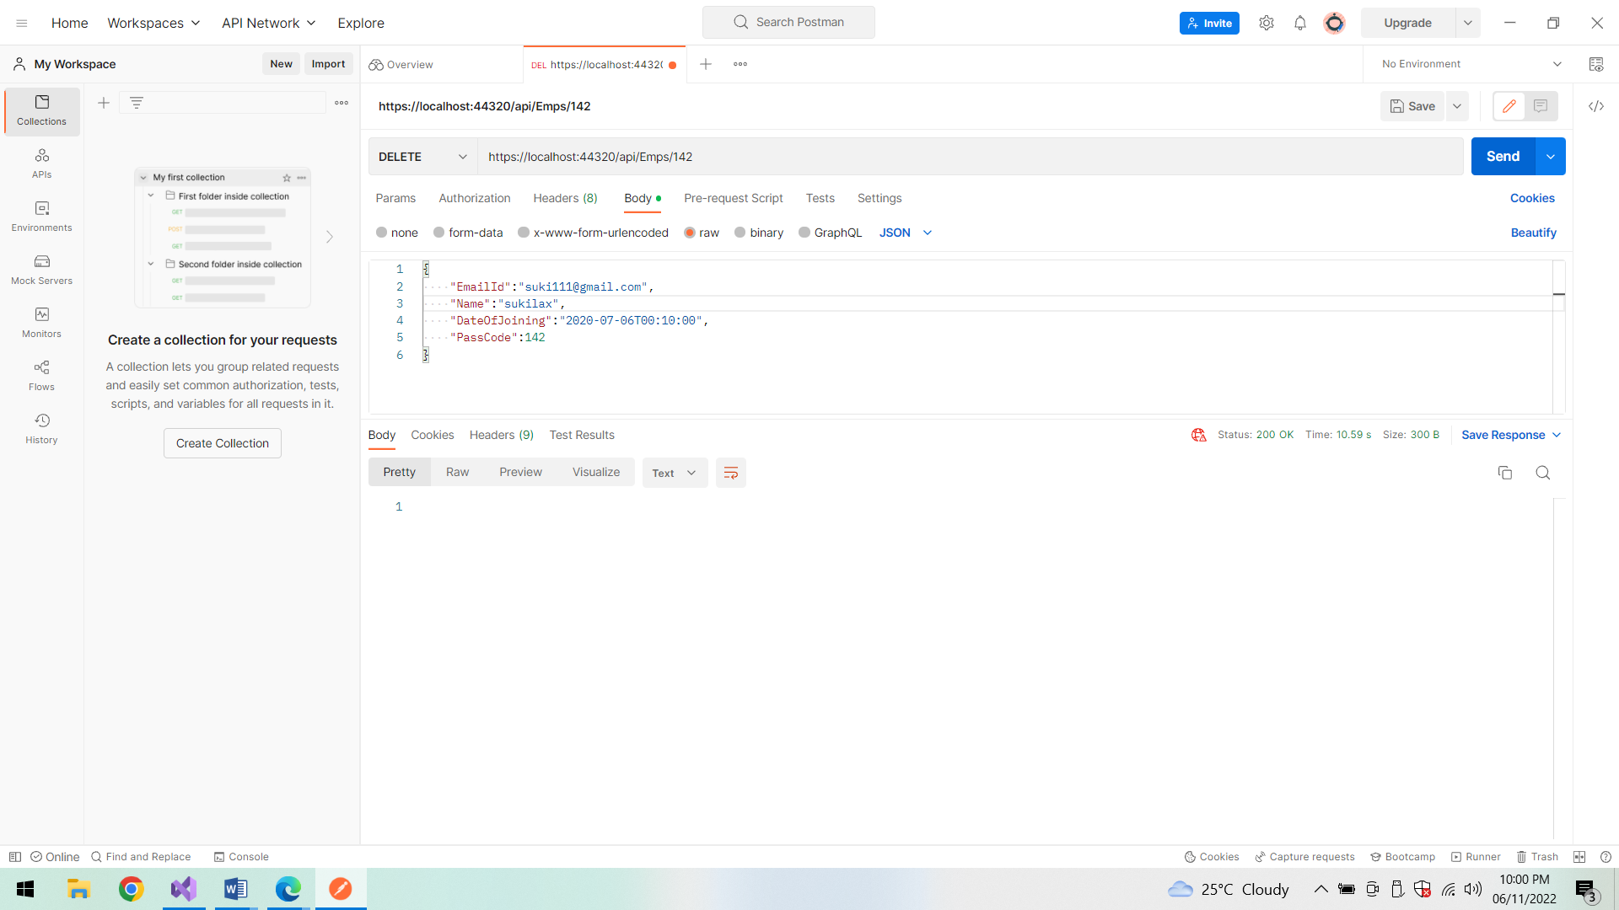

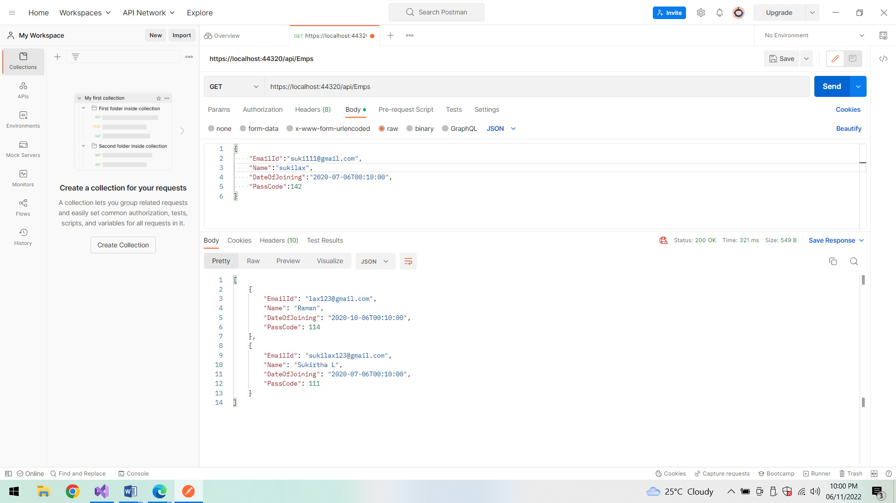

**Blog details:**

**GET:**

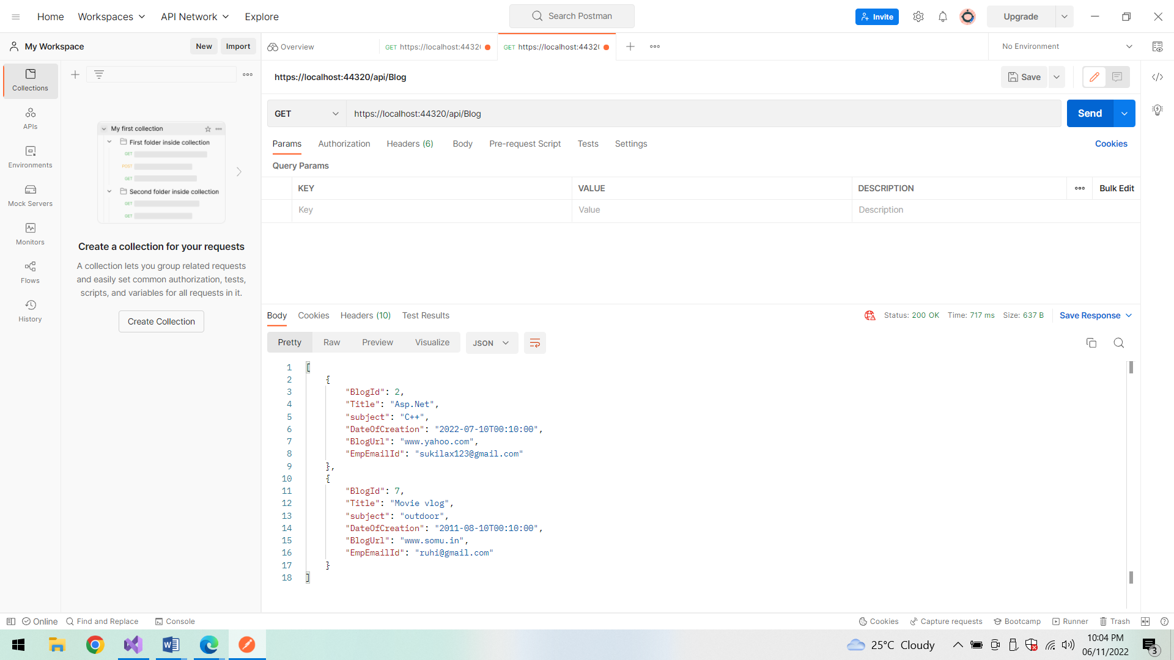

**POST:**

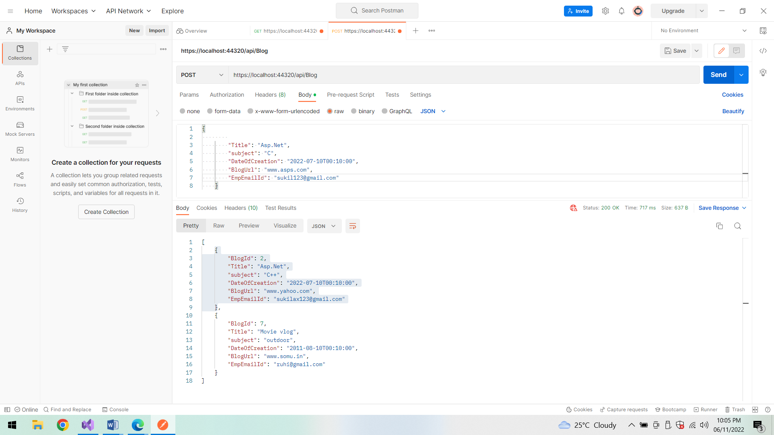

**Success status:**

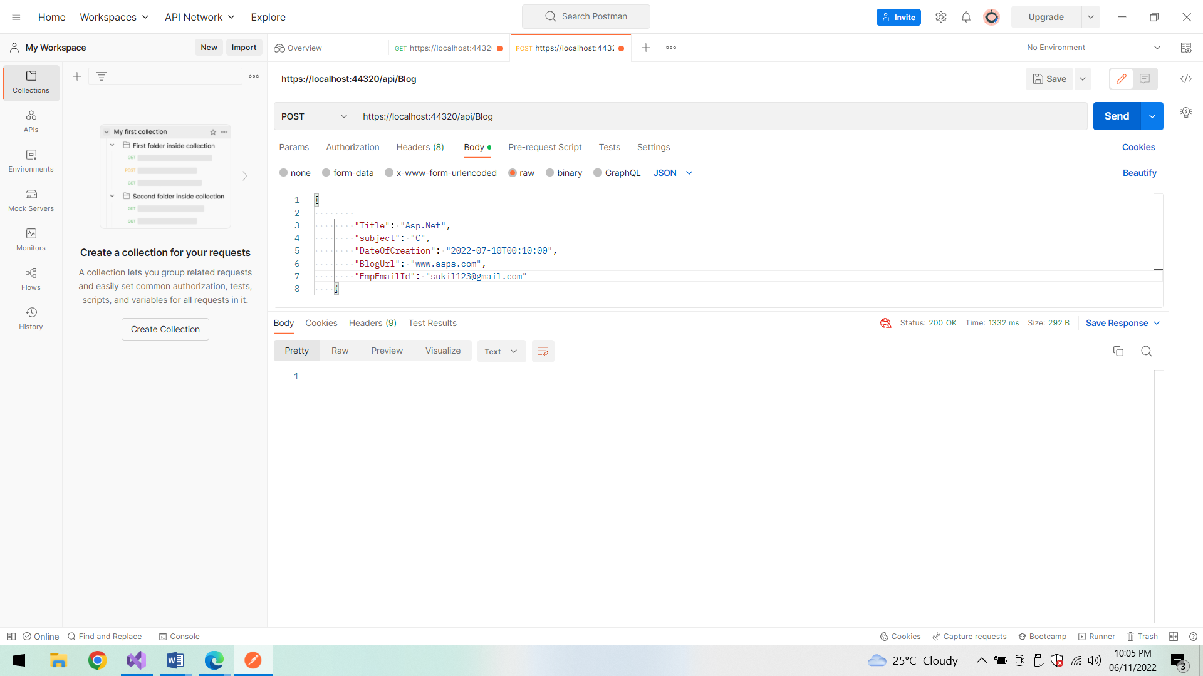

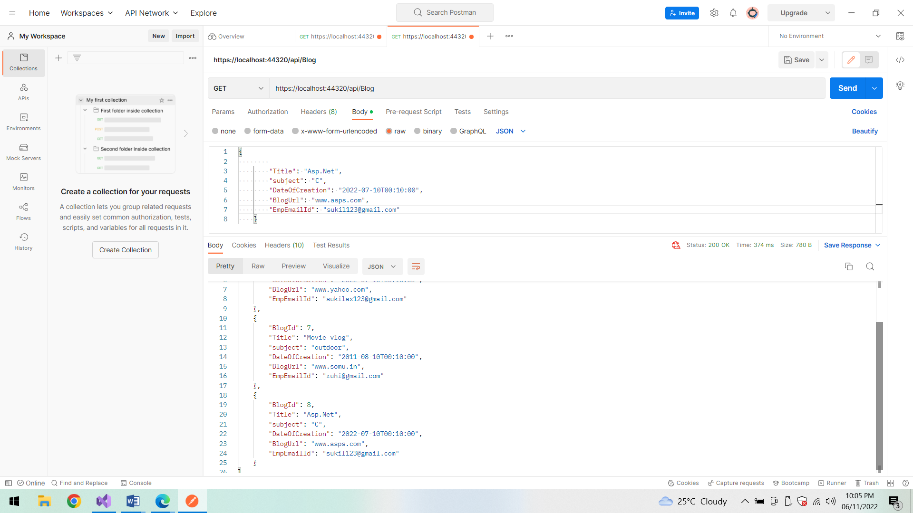

**Delete:**

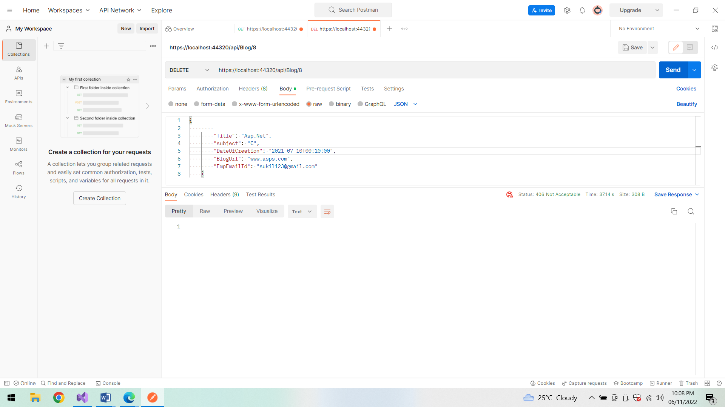

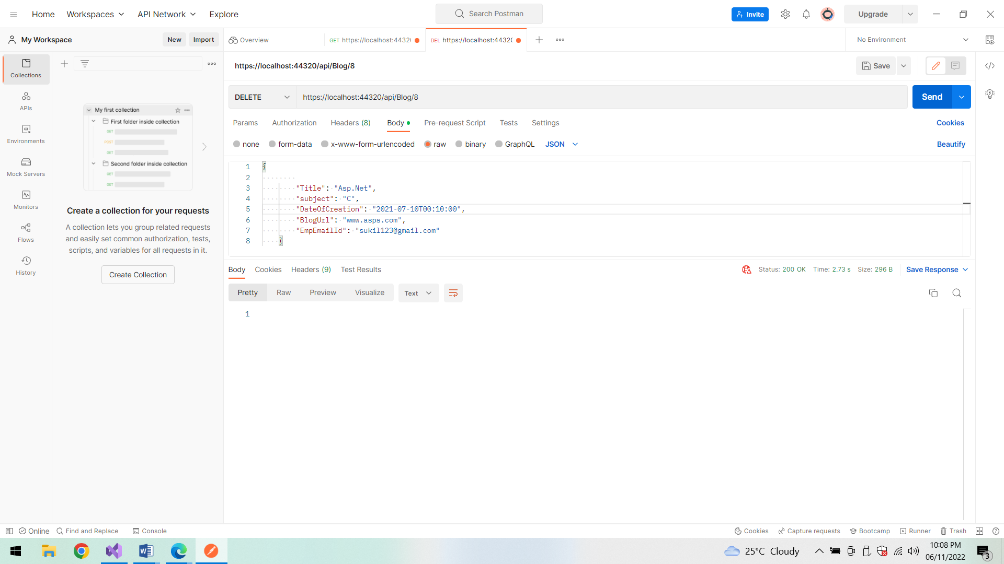

**After deletion:**

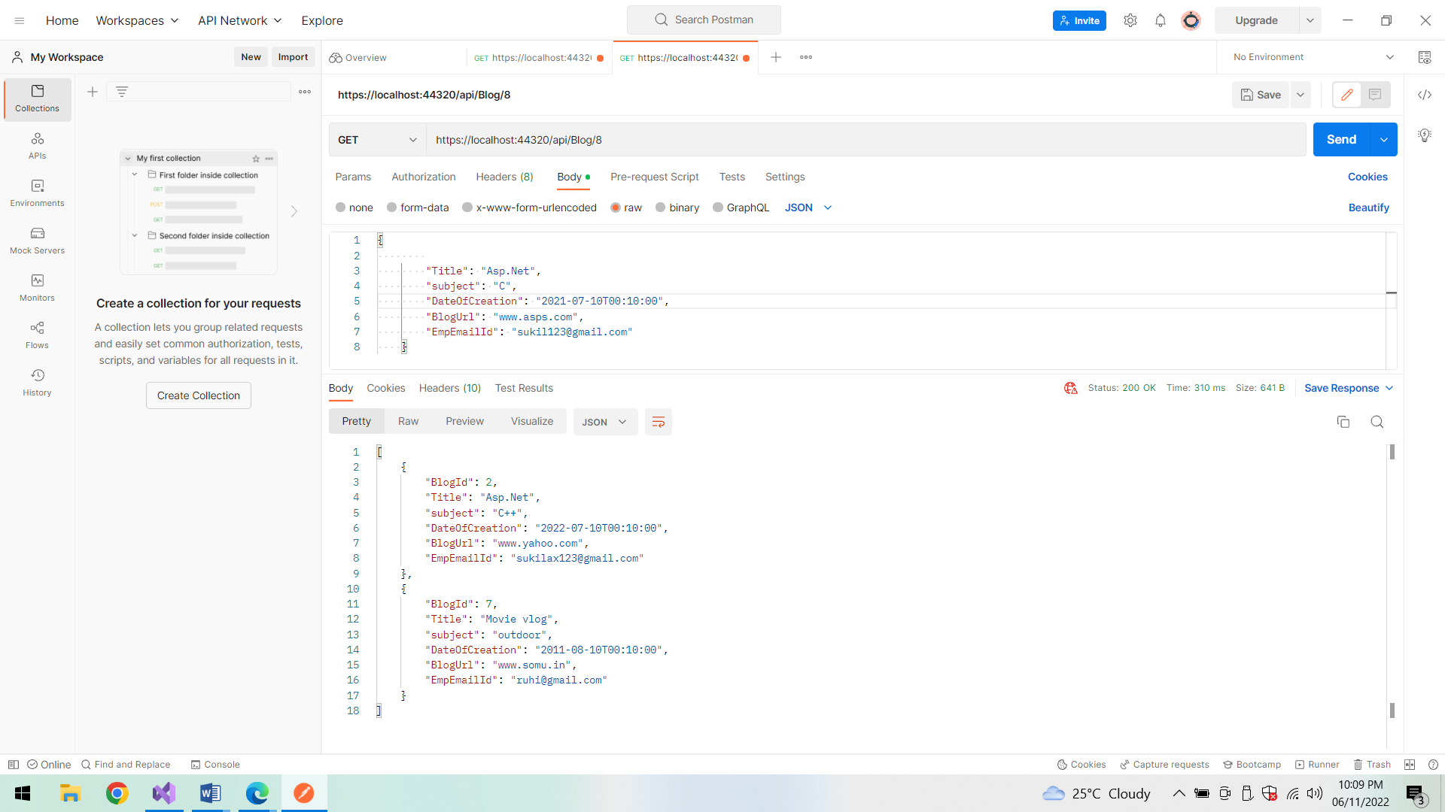

**PUT:**

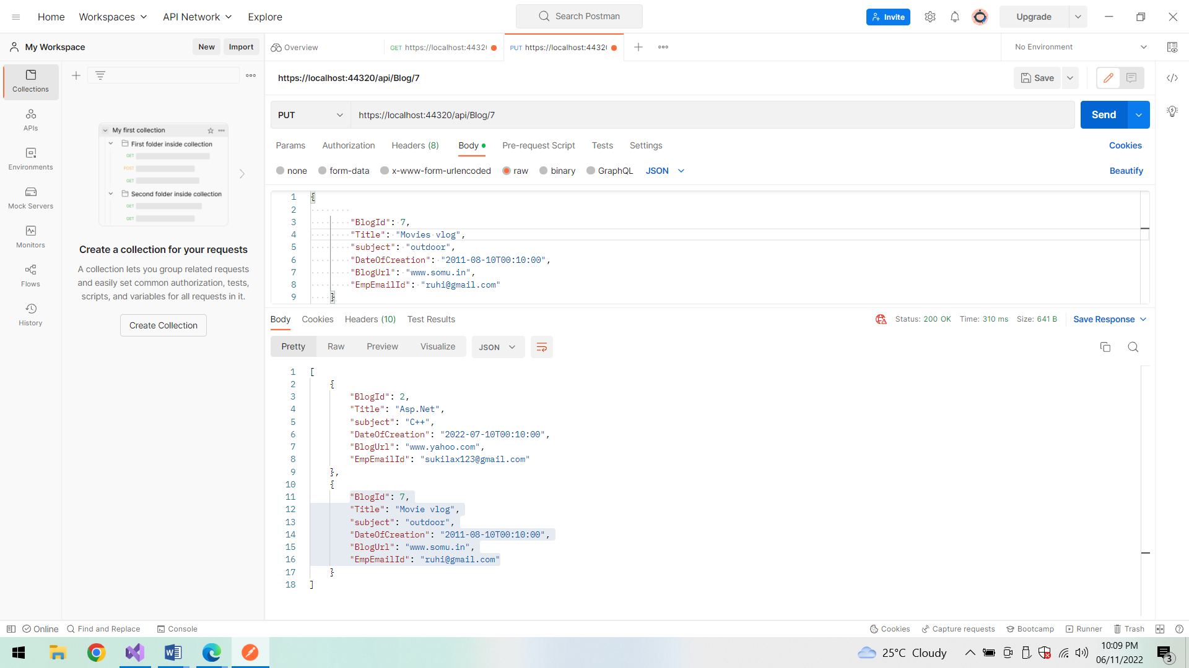

**Success status code:**

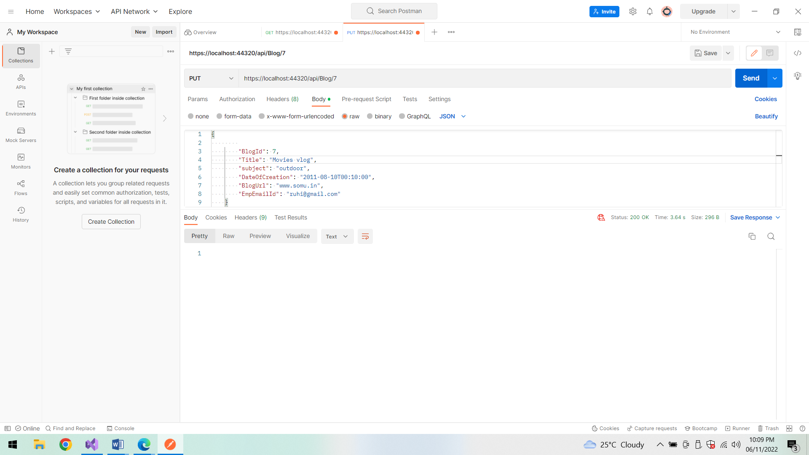

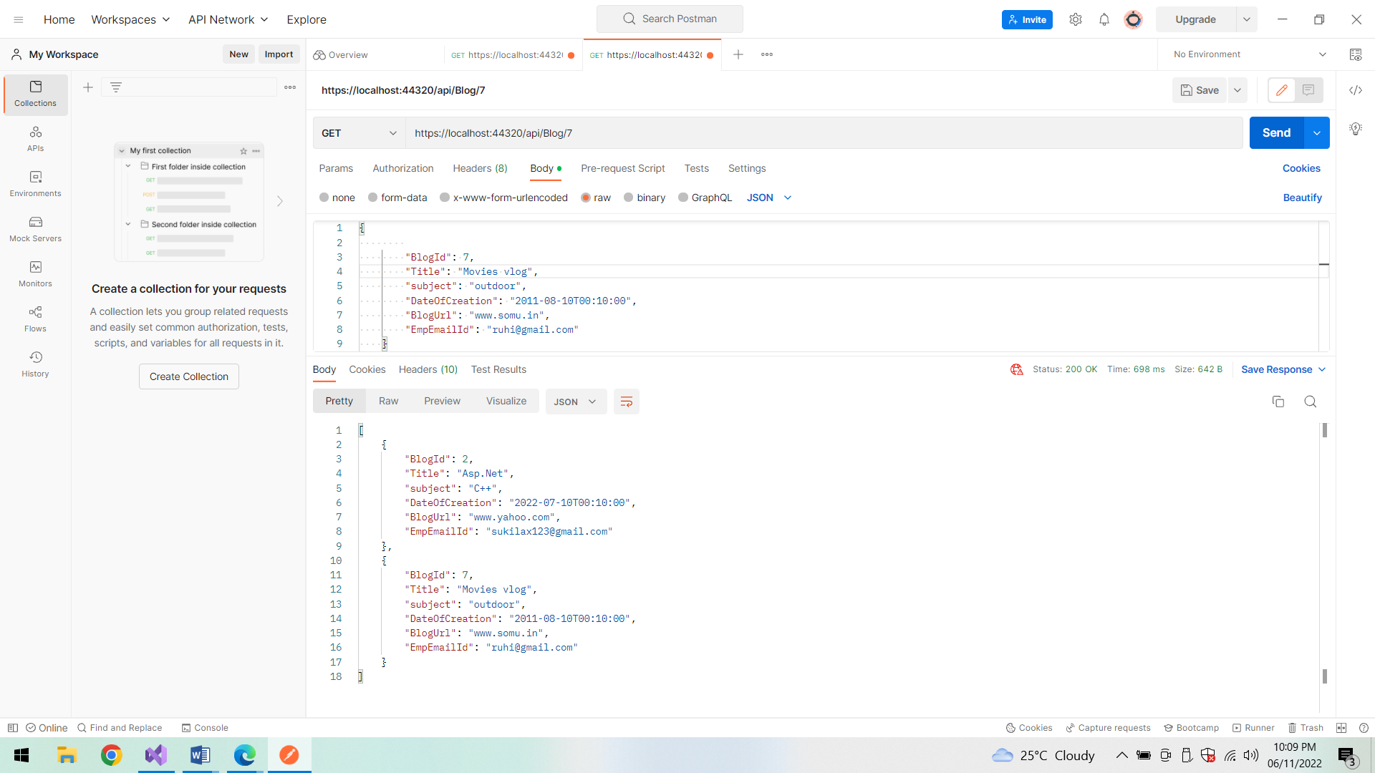

**Find Id(blog details):**

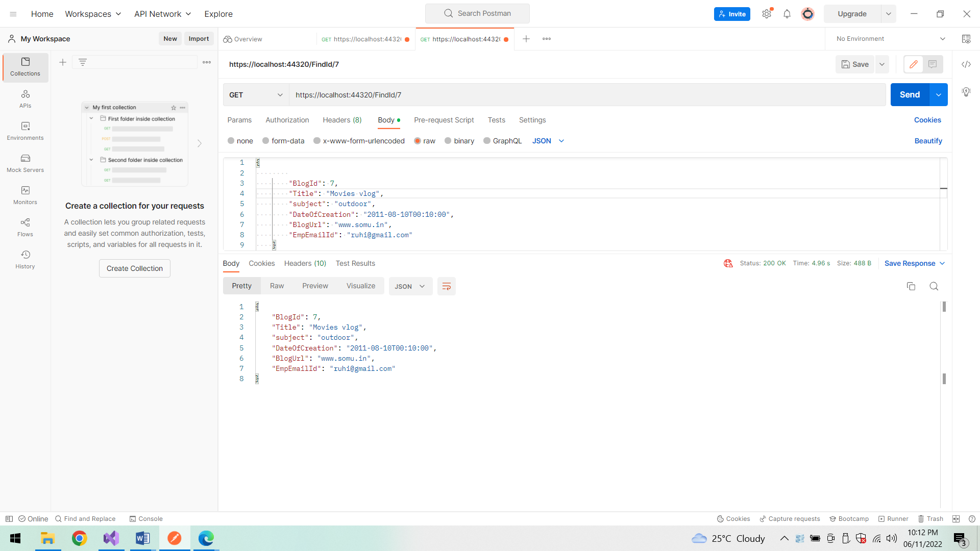

**Find by Id (Employee details):**

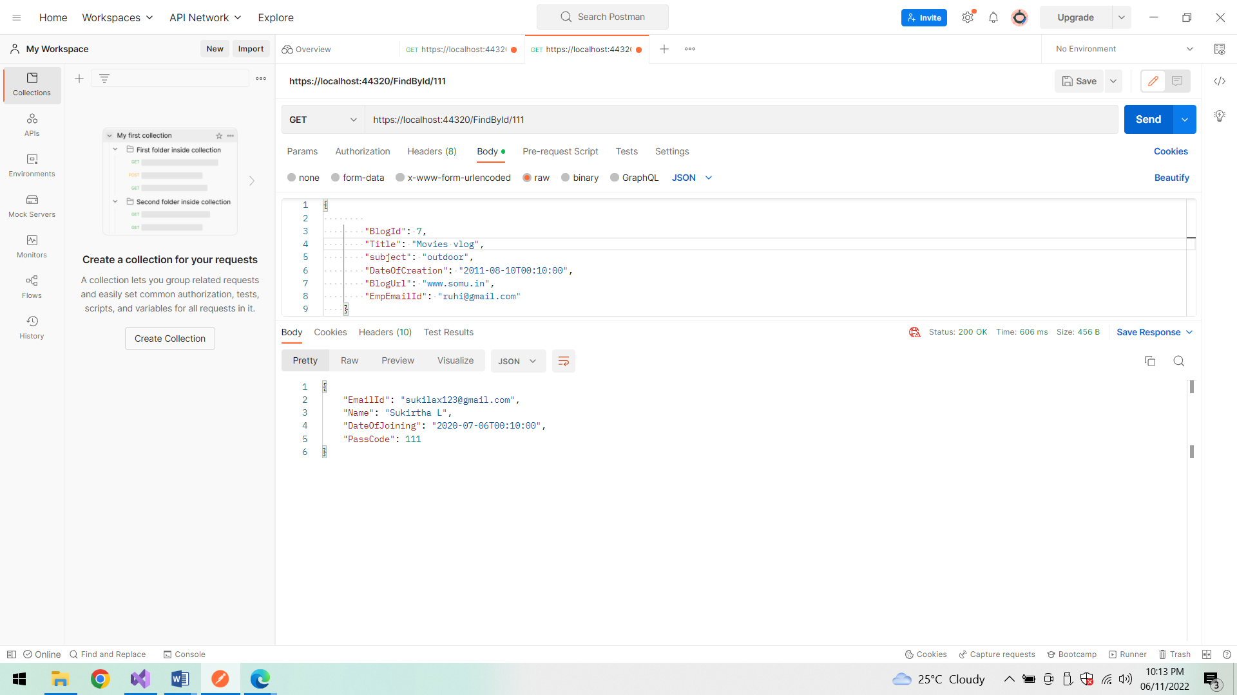

**Docker:**

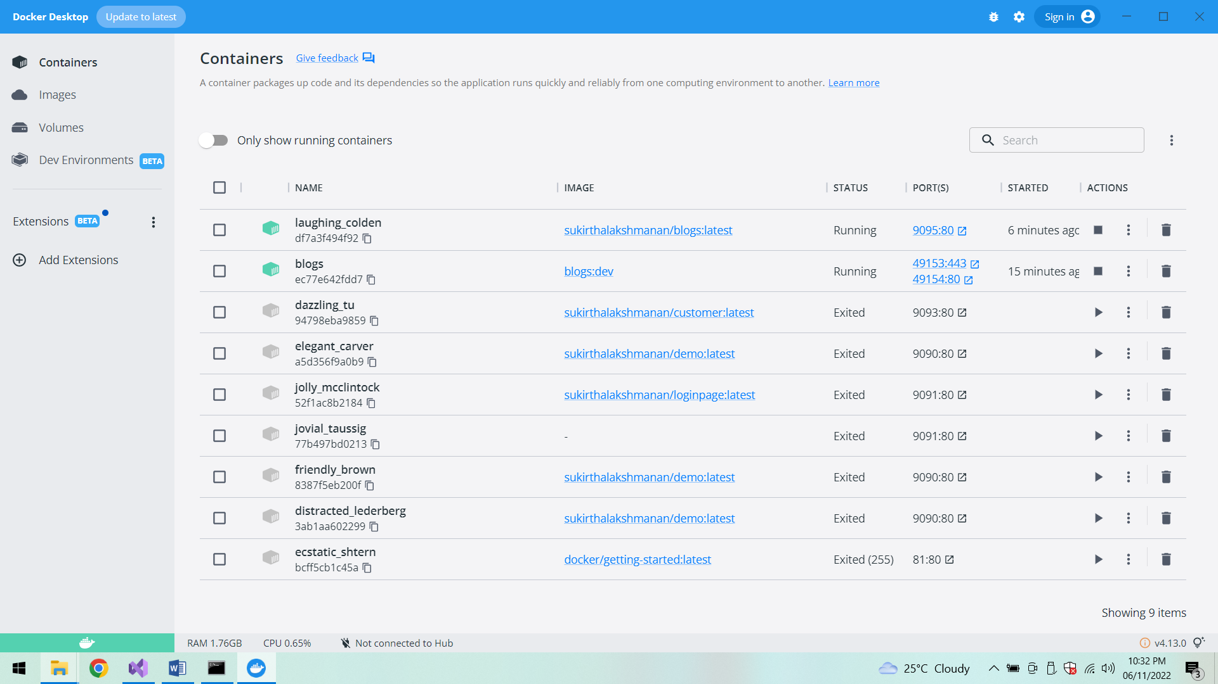

**Jenkins(Capstone project):**

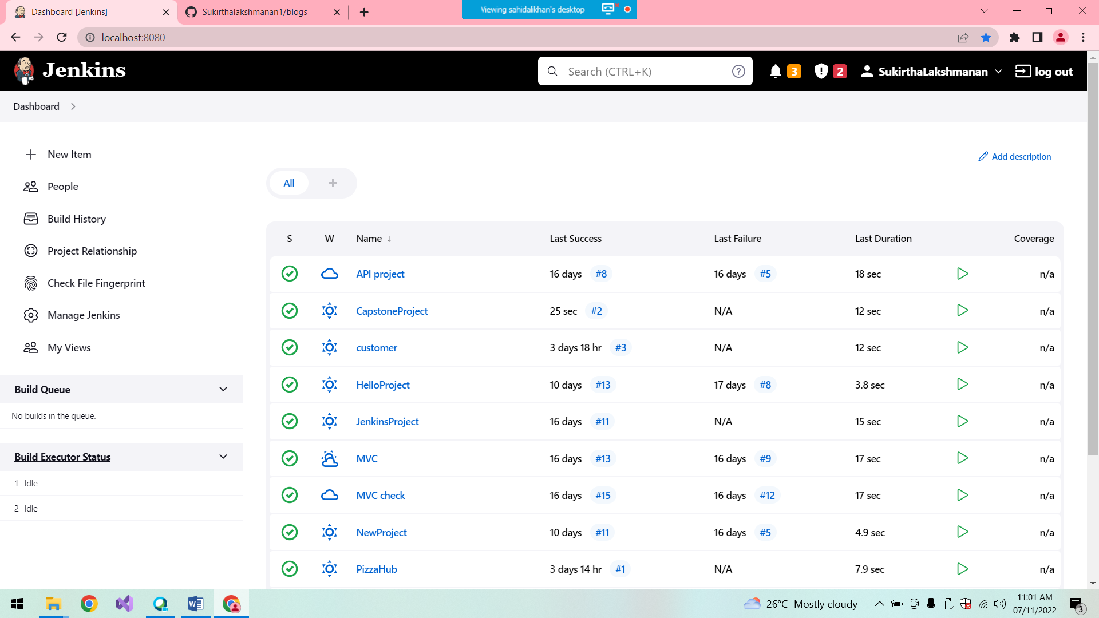

**After successful build:**

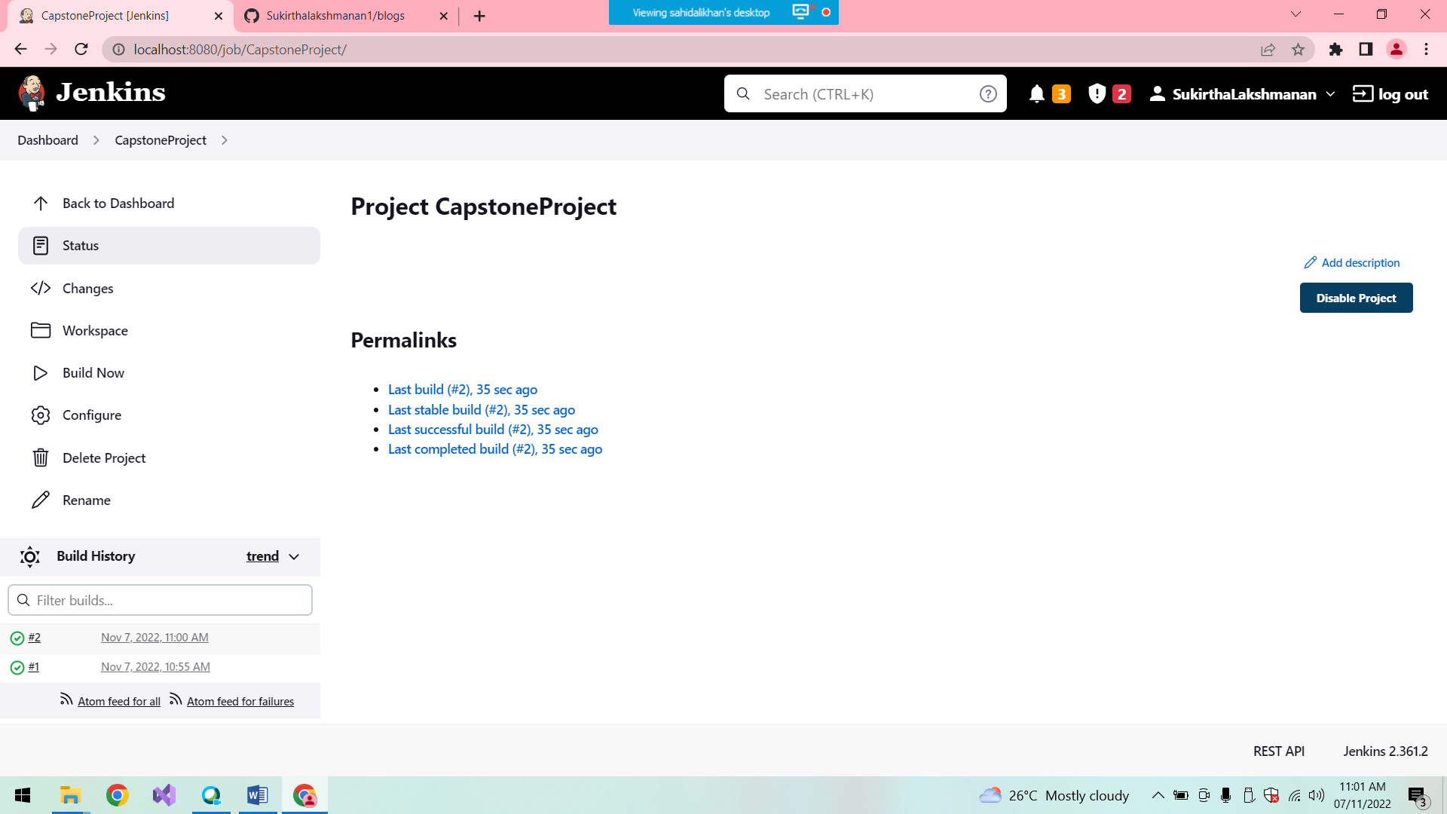

**Build 1 console output:**

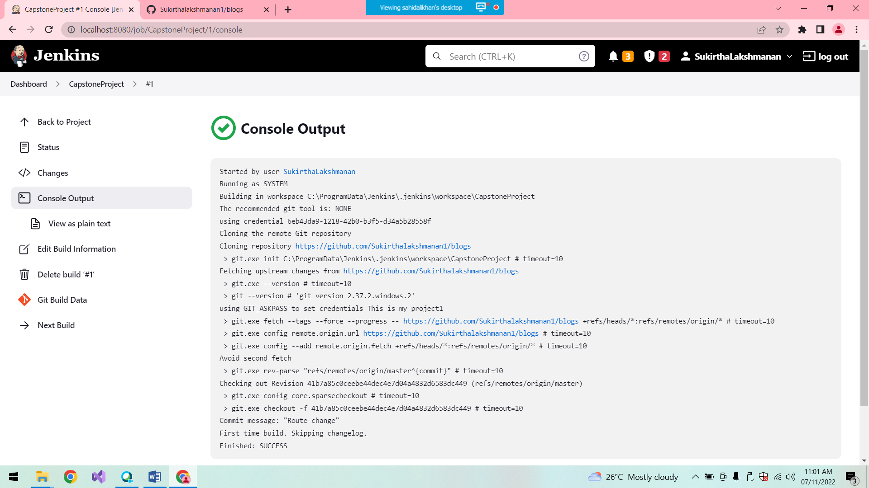

**Build 2:**

**Console output:**

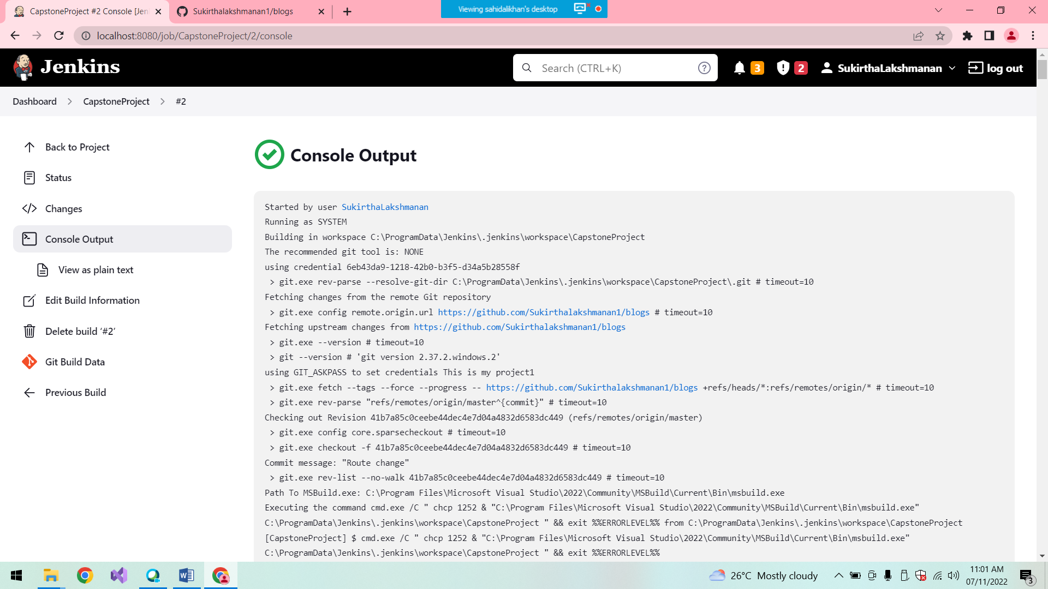

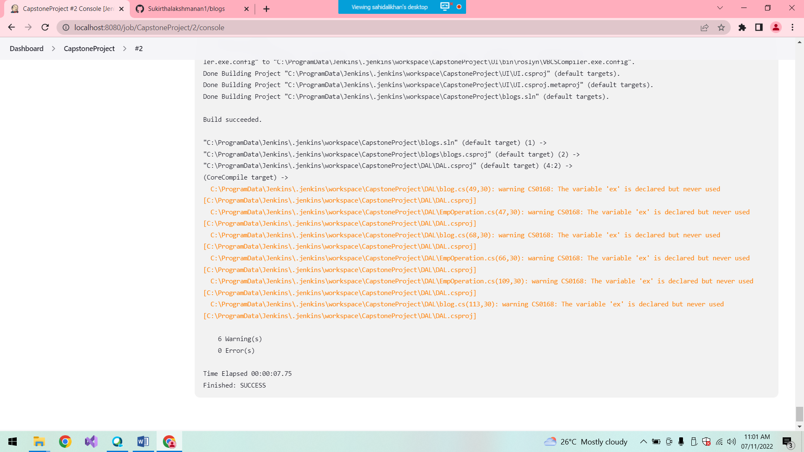

**Conclusion:**

Thus the Full Stack Application is created successfully.